

Requirement & Design Specification

**Football Booking Ticket**

**Version: 1.0**

| **SWP391_SU24_G5** | | | | | | | | | |
| --- | --- | --- | --- | --- | --- | --- | --- | --- | --- |
|
| | **Group Members** | | --- | | | **1** | **Đỗ Đức Vinh** | | | | | **HE172487** | |
| **2** | **Trần Anh Quân** | | | | | **HE170941** | |
| **3** | **Nguyễn Cảnh Dương** | | | | | **HE173192** | |
| **4** | **Quách Thế Kiệt** | | | | | **HE172485** | |
| **5** | **Đỗ Tiến Thuật** | | | | | **HE173070** | |
| **Supervisor** | | **Nguyễn Văn An** | | | | | |  | |

– Hanoi, May 2024 –

# Record of Changes

| **Version** | **Date** | **A* M, D** | **In charge** | **Change Description** |
| --- | --- | --- | --- | --- |
| V1.0 | 15/2 | A |  |  |
|  | 29/05/2024 | M | Kiệt | Modified use cases description in 1.2 for Football Club Management and Stand Management |
|  | 29/05/2024 | M | Kiệt | Modified screen description in 2.2 for Manage Stand and Manage Football Club |
|  | 29/05/2024 | M | Kiệt | Modified Screen Authorization 2.3 for Manage Stand and Manage Football Club |
|  | 29/05/2024 | M | Kiệt | Modified Use Cases Diagram 1.2.a for Customer and Guest |
|  | 29/05/2024 | M | Dương | Modified use case diagram 1.2.a for ticket inspector |
|  | 29/05/2024 | A | Kiệt | Add Stand Management in ll. Requirement Specification |
|  | 29/05/2004 | A | Dương | Add usecase “Delete News” in 2.1.b |
|  | 29/05/2024 | M | Dương | Modified Screen Authorization 2.3 for History Purchased and Manage News |
|  | 29/05/2024 | M | Quân | Modified Common Functions for 2.1 Login System |
|  | 29/05/2024 | A | Quân | Add Register in 2.Common Functions |
|  | 29/05/2024 | A | Quân | Add User Access in lll. Screen Designs |
|  | 29/05/2024 | M | Kiệt | Modified Stand Management in ll. Requirement Specification |
|  | 30/05/2024 | A | Kiệt | Added Stand Management in lll. Screen Designs |
|  | 30/05/2024 | M | Dương | Modified News Management in ll. Requirement Specification |
|  | 30/05/2024 | A | Dương | Added Management News in lll. Screen Designs |
|  | 30/05/2024 | A | Dương | Added Management News in 2.2 Screen Descriptions |
|  | 30/05/2924 | M | Kiệt | Modified Stand Management and Football Club Management in lll. Screen Designs |
|  | 30/05/2024 | M | Kiệt | Modified Database Schema |
|  | 30/05/2024 | M | Vinh | Modified Actors |
|  | 30/05/2024 | A | Vinh | Added Context Diagram |
|  | 30/05/2024 | M | Vinh | Modified Screens Description |
|  | 30/05/2024 | M | Vinh | Added Screens Authorization |
|  | 30/05/2024 | A | Vinh | Added UCs User Management |
|  | 30/05/2024 | A | Vinh | Added UCs Role Management |
|  | 30/05/2024 | A | Vinh | Added UCs Season Management |
|  | 30/05/2024 | M | Vinh | Modified ScreenFlow UserList,RoleList,SeasonList |
|  | 30/05/2024 | A | Thuật | Add Use Case 4 Match Management |
|  | 30/05/2024 | A | Thuật | Add Screen Designs 4. Match Management |
|  | 30/05/2024 | M | Thuật | Modified Screenflow for Match management |
|  | 30/05/2024 | A | Kiệt | Added table description |
|  | 02/06/2024 | A | Kiệt | l.2.1 Added screen flow for guest and customer, l.3.2 Added Code Packages |
|  | 02/06/2024 | A | Kiệt | Added non ui functional |
|  | 02/06/2024 | M | Kiệt | l.2 Modified Screen Description of Manage Football Club |
|  | 10/06/2024 | A | Kiệt | lll.4 Screen Designs: Added Football Club Management |
|  | 14/06/2024 | M | Kiệt | lll.4 Screen Designs: Modified Football Club Management |
|  | 14/06/2024 | A | Kiêt | ll.3 Requirement Specification: Added Football Club Management |
|  | 20/06/2024 | A | Kiệt | lV Code Designs: Added List Football Clubs, Create Football Club, Update Football Club, List Stands, Create Stand, Update Stand  ll.9 Added View My Tickets ll.10 Added Dashboard |
|  | 26/06/2024 | A | Quân | I.2.4 Added Non-UI functional for User |
|  | 26/06/2024 | M | Quân | lll.1 Modified User Access |
|  | 26/06/2024 | M | Quân | lll.2.1 Modified Common Access |
|  | 26/06/2024 | M | Quân | lll.2.2 Modified Common Access |
|  | 26/06/2024 | A | Quân | III.1.2 Add Password Change |
|  | 26/06/2024 | A | Quân | III.1.3 Add Logout |
|  | 26/06/2024 | A | Quân | III.1.4 Add Password Reset |
|  | 26/06/2024 | A | Quân | III.2.3 Add Instructions For Buy Tickets |
|  | 26/06/2024 | A | Quân | III.2.4 Add View About Us |
|  | 26/06/2024 | A | Quân | III.8.2 Add Create Season |
|  | 26/06/2024 | A | Dương | I.2.2 Screen Descriptions |
|  | 26/06/2024 | M | Dương | I.2.3 Screen Authorization |
|  | 26/06/2024 | A | Dương | II.2.9. History Purchased Ticket |
|  | 26/06/2024 | A | Vinh | II.5.3 Added UCs Create User,II.5.4 Added UCs Update User,II.5.5 Added UCs Change Status User |
|  | 26/06/2024 | A | Dương | III.10. Ticket Management |
|  | 15/07/2024 | M | Kiệt | l.1.2.b Modified Use Cases Description |
|  | 15/07/2024 | M | Quân | I.1.2.a Modified Diagram Customer |
|  | 15/07/2024 | M | Quân | I.2.1.3 Modified Customer |
|  | 15/07/2024 | A | Quân | IV. Add 12.2 Sequence Diagram |
|  | 18/07/2024 | A | Quân | V.1 Add Assumptions & Dependencies |
|  | 18/07/2024 | A | Quân | V.2 Add Limitations & Exclusions |
|  | 18/07/2024 | A | Quân | V.3 Add Business Rules |
|  | 18/07/2024 | M | Quân | I. Modified Overview |
|  | 18/07/2024 | M | Quân | I.2.2.4 Modified Non-UI Functions |
|  | 18/07/2024 | M | Quân | I.3.3.1 Modified Database Schema |
|  | 18/07/2024 | A | Kiệt | lV.1,2,3,4 Added Class Diagram |
|  | 18/07/2024 | M | Kiệt | l.2.2.b Modified Screen Description, l.2.2.1 Modified Admin’s Screen Flow, l.1.2.a Modified Admin’s Use Case Diagram |
|  | 18/07/2024 | M | Dương | I.1.1.2 Modified Use Cases Guest |
|  | 18/07/2024 | M | Dương | I.2.2.1 Modified Screens Flow Guest |
|  | 18/07/2024 | M | Dương | IV.2,3.4. Modified Screen Flow |
|  | 18/07/2024 | M | Vinh | I.1 Modified Context Diagram |
|  | 18/07/2024 | M | Vinh | I.2.2.b Modified Use case Description |
|  | 18/07/2024 | M | Vinh | I.3.2 Modified Screen Authorization |
|  | 18/07/2024 | M | Vinh | I.3.2 Modified Screen Description |
|  | 18/07/2024 | D | Vinh | II Deleted Ucs Role Management |
|  | 18/07/2024 | D | Vinh | III Deleted Search User,Change Status of User. |
|  | 27/07/2024 | A | Thuật | V.3 add Business rule for manage Match(BR-13, 14, 15, 16) |
|  | 27/07/2024 | A | Vinh | V.2. Added Limitation of device in scan QR code |

*A - Added M - Modified D - Deleted

Contents

Record of Changes 2

I. Overview 10

1. Context Diagram 10

2. User Requirements 10

2.1 Actors 10

2.2 Use Cases 11

3. Overall Functionalities 17

3.1 Screens Flow 17

3.2 Screen Descriptions 19

3.3 Screen Authorization 23

3.4 Non-UI Functions 25

4. System High Level Design 25

4.1 Database Design 25

4.2 Code Packages 28

II. Requirement Specifications 31

1. Common Functions 31

1.1 Login 31

1.2 Register 31

2. Stand Management 32

2.1 View List Stands 32

2.2 Create Stand 33

2.3 Update Stand 34

2.4 Delete Stand 35

a. UC Specifications 35

3. Football Club Management 36

3.1 View List Football Clubs 36

3.2 Create Football Club 36

2.3 Update Football Club 37

2.4 Delete Football Club 38

a. UC Specifications 38

4. Match Management 39

4.1 View List Match 39

4.2 Create Match 40

4.3 Delete Match 40

4.4 Update Match 41

5. User Management 42

5.1 View List User 42

5.2 Search User 42

5.3 Create User 43

5.4 Update User 45

5.5 Change status user 47

6. Season Management 49

6.1 View List Season 49

7. News Management 50

7.1 View List news 50

7.2 Create news 50

7.3 Update news 51

7.4 Delete news 52

a. UC Specifications 52

7.5. View News Details 53

View News Details 53

8. History Purchased Ticket Management 54

8.1 View List Ticket Match Seat 54

8.2 View List Ticket Season Seat 54

III. Screen Designs 55

1. User Access 55

1.1 User Login 55

1.2 Password Change 56

1.3 Logout 57

1.4 Password Reset 58

1.5 My Tickets 59

1.6 My Ticket Detail 60

1.7 Profile Edit 61

2. Common Access 62

2.1 User Register 62

2.2 Cate are password when registering with Gmail 63

2.3 Instructions For Buy Tickets 64

2.4 About Us 65

2.5 Public Match Detail 66

2.6 Summary Ticket 67

2.7 Public Match List 68

2.8 Public Tournament List 70

2.9 Public Football Club List 71

2.10 Public News List 72

2.11 Public News Detail 73

2.12 Home Page 74

3. Stand Management 76

3.1 Stand List 76

3.2 New Stand 77

3.3 Stand Update 78

4. Football Club Management 79

4.1 Football Clubs List 79

4.2 New Football Club 80

4.3 Football Club Update 81

5. Match Management 82

5.1 Match List 82

5.2 New Match 83

5.3 Match Update 84

5.4 Delete Matches 85

6. User Management 85

6.1 User List 85

6.3 Create User 86

6.4 User Update 88

7. Season Management 89

7.1 Season List 89

7.2 New Season 89

8. News Management 90

8.1. News List 90

8.2. New News 91

8.3 News Update 94

9. Ticket Management 95

9.1. Ticket Match Seat List 95

9.2. Ticket Match Season Seat List 96

10. Dashboard 96

IV. Code Designs 97

1. Payment Method 97

1.1 Class Diagram 97

1.2 Sequence Diagram(s) 98

1.3 Database Queries 98

2. News List 99

2.1 Class Diagram 99

2.2 Sequence Diagram(s) 100

2.3 Database Queries 100

3. Create News 101

3.1 Class Diagram 101

3.2 Sequence Diagram(s) 102

3.3 Database Queries 102

4. Update News 103

4.1 Class Diagram 103

4.2 Sequence Diagram(s) 103

4.3 Database Queries 104

V. Appendix 104

1. Assumptions & Dependencies 104

2. Limitations & Exclusions 105

3. Business Rules 105

# I. Overview

## 1. [Context Diagram](https://online.visual-paradigm.com/share.jsp?id=333334313238392d32)

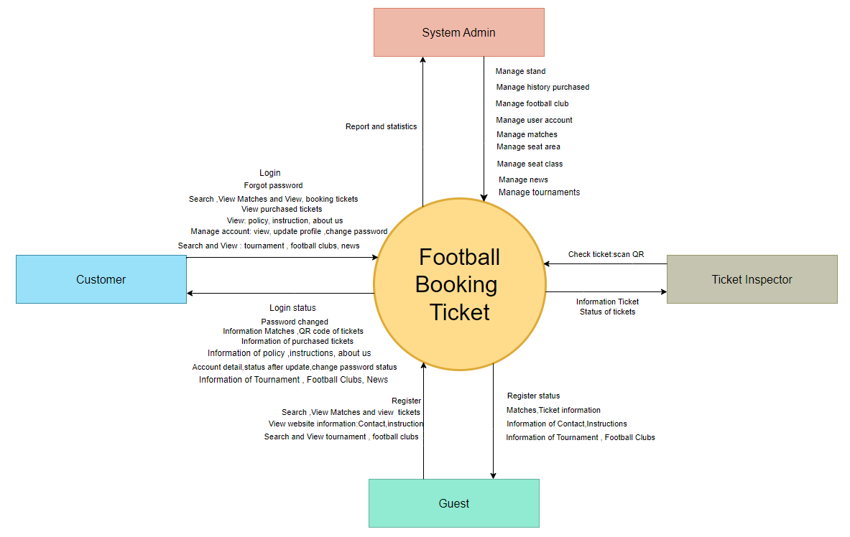

[**Context Diagram**](https://online.visual-paradigm.com/share.jsp?id=333334313238392d32)

## 2. User Requirements

### 2.1 Actors

| **#** | **Actor** | **Description** |
| --- | --- | --- |
| 1 | Guest | Individuals who haven't logged into the system. They can access information about matches, contact details, and ticket purchasing instructions, register for an account, and search for matches. |
| 2 | Admin | System administrators who have accounts logged into the system and have access to system management functions such as managing matches, purchase history, viewing reports and statistics, managing user accounts, football clubs, stands, news and seasons. |
| 3 | Customer | Registered users who have an account logged into the system. They can view match information, contact details, and ticket purchasing instructions, buy tickets, search for matches and stands, manage their accounts, review purchased tickets, and recover forgotten passwords. |
| 4 | Ticket inspector | Ticket inspection staff who have been tasked with scanning QR codes on electronic tickets at entrance gates to verify authenticity ticket information to confirm ticket validity. |

### 2.2 Use Cases

#### a. Diagram(s)

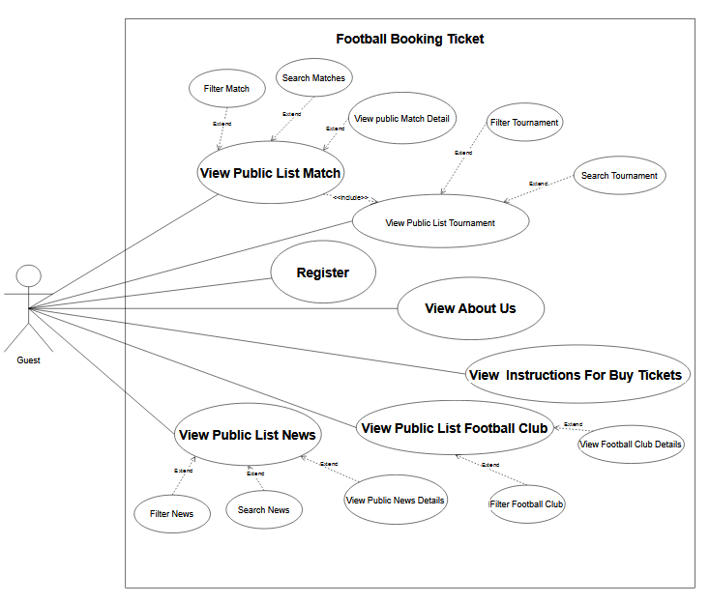

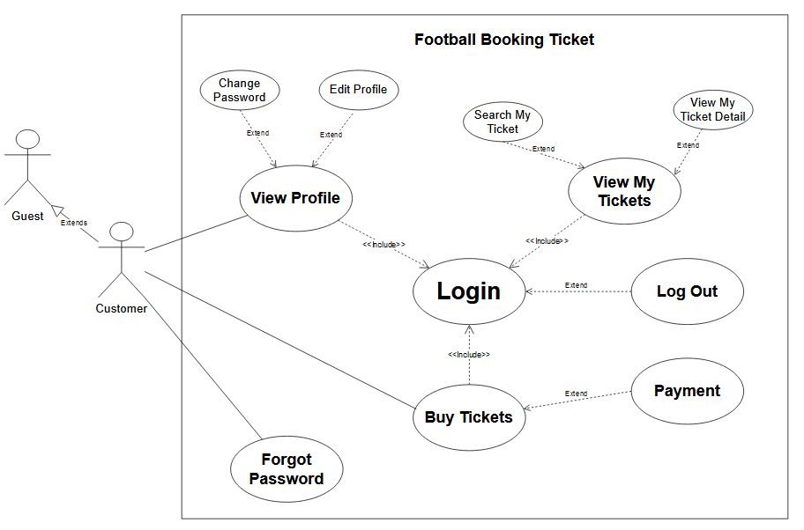

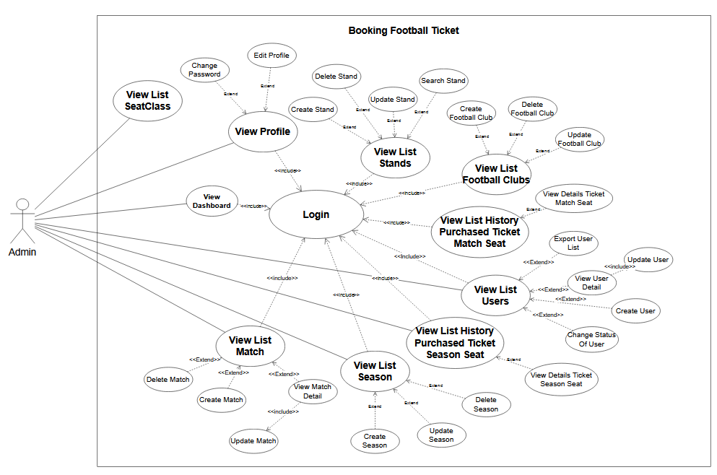

#### 

#### b. Descriptions

| **ID** | **Feature** | **Use Case** | **Use Case Description** |
| --- | --- | --- | --- |
| 1 | User Access | Login | Allows users to authenticate and gain access to the system by entering their credentials. |
| 2 | Change Password | Enables users to update their account password for enhanced security and account management. |
| 3 | Logout | Logs the user out of the system, terminating their session and ensuring the security of their account. |
| 4 | Edit Profile | Allows users to modify their profile information such as contact details and personal preferences. |
| 5 | View My Tickets | Displays the list of tickets purchased by the user, providing an overview of their ticket history. |
| 6 | Forgot Password | Assists users in recovering or resetting their password if they have forgotten it, typically through email verification. |
| 7 | View My Ticket Detail | Provides detailed information about a specific ticket purchased by the user, including match details and seat allocation. |
| 8 | View Ticket Summary | Summarizes the user's ticket purchases, providing an overview of their tickets and associated details. |
| 9 | Search My Ticket | Allows users to search for specific tickets based on criteria such as match date or seat location. |
| 10 | Common Access | View Public Match Detail | Shows detailed information about a specific match, including teams, date, and venue. |
| 11 | View Public Football Club Detail | Provides detailed information about a specific football club, including roster, history, and achievements. |
| 12 | View Public List Football Club | Displays a list of all football clubs available to the public, including basic information and club names. |
| 13 | Search Public Football Club | Allows users to search for specific football clubs within the public listings. |
| 14 | View Public List Match | Displays a list of all available matches to the public, including details like date and time. |
| 15 | Search Public Match | Allows users to search for specific matches based on criteria such as date, teams, or location. |
| 16 | View Public List Tournament | Displays a list of all tournaments available to the public, including details like dates and participating teams. |
| 17 | Search Public Tournament | Enables users to search for specific tournaments within the public listings. |
| 18 | Term & Conditions | Provides users with information on the terms and conditions of using the system. |
| 19 | View Instructions For Buy Tickets | Provides users with step-by-step instructions on how to purchase tickets through the system. |
| 20 | Homepage | The main landing page of the website where users can navigate to different sections of the application. |
| 21 | Register | Allows users to create a new account by providing necessary personal information and setting up login credentials. |
| 22 | View Public List News | Displays a list of news articles related to the system or organization, keeping users updated. |
| 23 | View Policy | Provides information about the organization’s policies. |
| 24 | View About Us | Provides information about the organization, including its mission, history, and contact details. |
| 25 | View News Detail | Shows detailed information about a specific news article, including full text and relevant images. |
| 26 | User Management | View List User | Displays a list of all users registered in the system, including their basic information and status. |
| 27 | Search User | Allows administrators to search for specific users within the system based on criteria such as name or email. |
| 28 | Export User List | Enables exporting the user list to a file format (e.g., CSV or Excel) for reporting or analysis. |
| 29 | Create User | Allows administrators to create a new user account with necessary information and permissions. |
| 30 | View User Detail | Provides detailed information about a specific user, including profile and activity details. |
| 31 | Delete User | Allows the removal of a user account from the system, including associated data and permissions. |
| 32 | Match Management | View List Matches | Displays a list of all matches within the system, including match details and statuses. |
| 33 | Search Matches | Allows users to search for specific matches based on criteria such as date, teams, or location. |
| 34 | View Matches Details | Provides detailed information about a specific match, including teams, date, and venue. |
| 35 | Create Matches | Allows the creation of new match entries within the system, including all relevant details. |
| 36 | Update Matches | Enables updating information of existing matches, such as date, time, and participating teams. |
| 37 | Delete Matches | Allows the removal of a match from the system, including any associated data. |
| 38 | History Purchased Management | Inspect Ticket | Provides detailed inspection of a specific ticket, including its status and history. |
| 39 | View History Purchased Ticket Match Seat | Displays a list of all purchased match seat records, providing an overview of historical transactions. |
| 40 | Search History Purchased Ticket Match Seat | Allows searching for specific purchase records based on criteria such as date or match. |
| 41 | Export History Purchased Ticket Season Seat | Enables exporting the purchase history list for season seats to a file format for reporting or analysis. |
| 42 | Export History Purchased Ticket Match Seat | Enables exporting the purchase history list for match seats to a file format for reporting or analysis. |
| 43 | View History Purchased Ticket Season Seat | Provides detailed information about season seat purchases, including transaction details and seat allocation. |
| 44 | View List History Purchased Ticket Match Seat | Displays a list of each match with ticket already purchased match seat records, providing an overview of historical transactions. |
| 44 | Football Club Management | View List Football Clubs | Displays a list of all existing football clubs within the system, including basic information and status. |
| 45 | Search Football Club | Allows searching for specific football clubs within the system based on criteria such as name or location. |
| 46 | Create Football Club | Enables the creation of a new football club entry in the system with all necessary details. |
| 47 | Update Football Club | Allows updating information of an existing football club, including roster and details. |
| 48 | Delete Football Club | Enables the removal of a football club from the system, retaining data in the database. |
| 49 | Stand Management | View List Stands | Displays a list of all stands within the system, including their names and locations. |
| 50 | Search Stand | Allows searching for specific stands within the system based on criteria such as name. |
| 51 | Create Stand | Enables the creation of a new stand entry in the system, including details such as name and capacity. |
| 52 | Update Stand | Allows updating information of an existing stand, such as name or capacity. |
| 53 | Delete Stand | Enables the removal of a stand from the system, retaining data in the database. |
| 54 | News Management | View List News | Displays a list of all news articles in the system, including headlines and publication dates. |
| 55 | Search News | Allows searching for specific news articles within the system based on criteria such as title or date. |
| 56 | View News Details | Shows detailed information about a specific news article, including full text and relevant images. |
| 57 | Delete News | Allows the removal of a news article from the system, including associated media and content. |
| 58 | Create News | Enables the creation of a new news article entry in the system, including text and media content. |
| 59 | Update News | Allows updating information of an existing news article, including text and media content. |
| 60 | Season Management | View List Season | Displays a list of all seasons in the system, including details such as season name and duration. |
| 61 | Create Season | Enables the creation of a new season entry in the system with relevant details. |
| 62 | Search Season | Allows searching for specific seasons within the system based on criteria such as name or date. |
| 63 | Update Season | Enables updating information of an existing season, such as name or duration. |
| 64 | Delete Season | Enables the removal of a season from the system, retaining data in the database. |
| 65 | SeatArea Management | View List SeatArea | Displays a list of all seat areas within the system, including details such as location and capacity. |
| 66 | Update SeatArea | Allows updating details of seat areas, such as location and capacity. |
| 67 | SeatClass Management | View List SeatClass | Displays a list of all seat classes within the system, including class names and descriptions. |
| 68 | Update SeatClass | Enables updating information about seat classes, including class names and descriptions. |
| 69 | Payment Methods | Payment Methods | Displays and manages available payment methods for processing transactions. |
| 70 | Dashboard | Dashboard | Provides an overview of key metrics and system status, including summaries of user activity, ticket sales. |

## 3. Overall Functionalities

### 3.1 Screens Flow

3.1.1 Admin

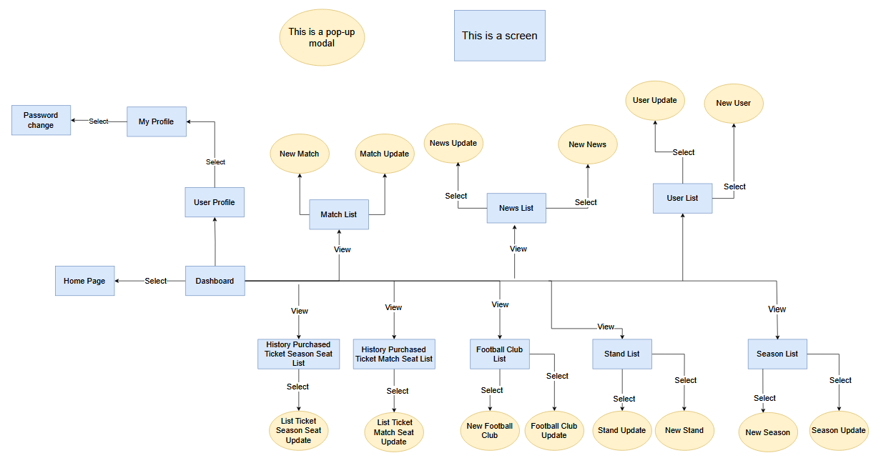

3.1.2 Guest

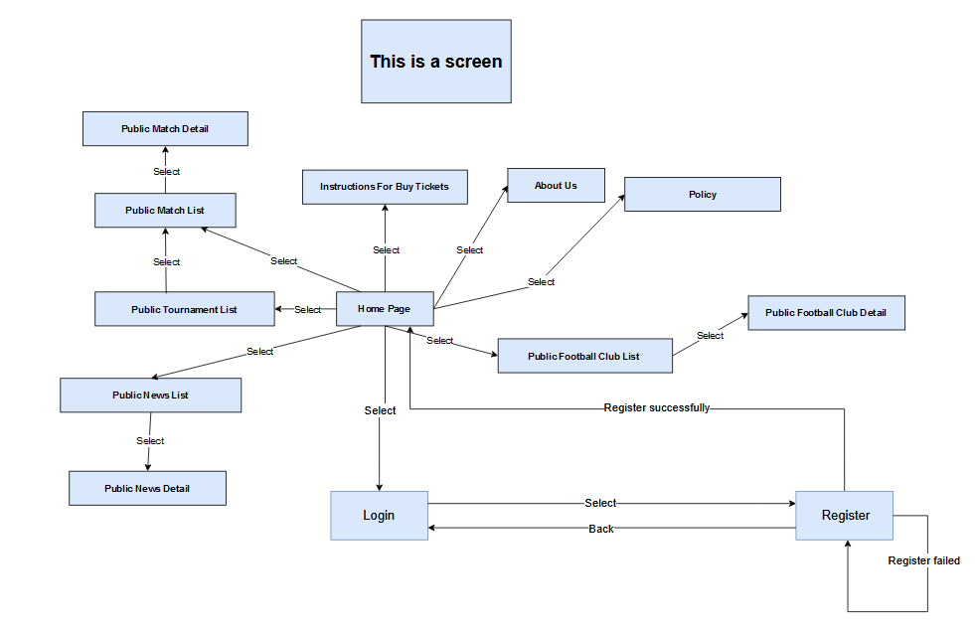

3.1.3 Customer

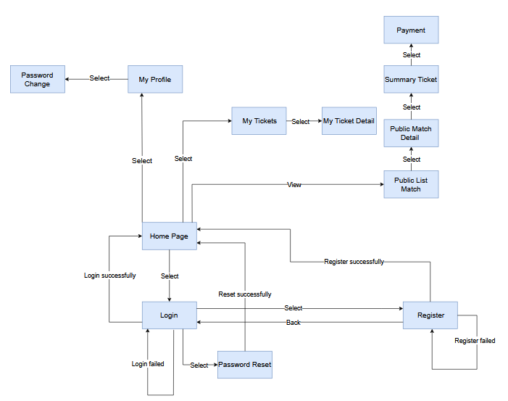

3.1.4 Inspector

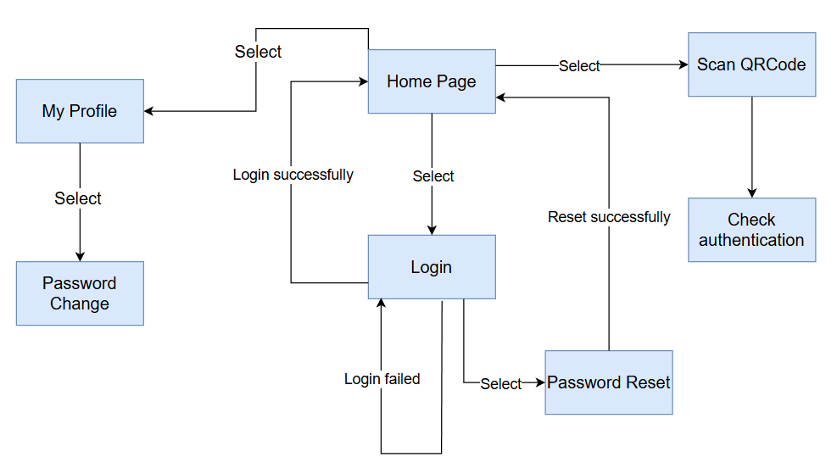

### 3.2 Screen Descriptions

| **#** | **Feature** | **Screen** | **Description** |
| --- | --- | --- | --- |
| 1 | User Access | Login | Allows users to authenticate and gain access to the system by entering their credentials. |
| 2 | Password change | Enables users to update their account password for enhanced security and account management. |
| 3 | Logout | Logs the user out of the system, terminating their session and ensuring the security of their account. |
| 5 | My Tickets | Displays the list of tickets purchased by the user, providing an overview of their ticket history. |
| 6 | Forgot Password | Assists users in recovering or resetting their password if they have forgotten it, typically through email verification. |
| 7 | My Ticket Detail | Provides detailed information about a specific ticket purchased by the user, including match details and seat allocation. |
| 8 | Ticket Summary | Summarizes the user's ticket purchases, providing an overview of their tickets and associated details. |
| 10 | Common Access | Public Match Update | Shows detailed information about a specific match, including teams, date, and venue. |
| 11 | Public Football Club Update | Provides detailed information about a specific football club, including roster, history, and achievements. |
| 12 | Public List Football Club | Displays a list of all football clubs available to the public, including basic information and club names. |
| 13 | Public Football Club | Allows users to search for specific football clubs within the public listings. |
| 14 | Public List Match | Displays a list of all available matches to the public, including details like date and time. |
| 15 | Public Match | Allows users to search for specific matches based on criteria such as date, teams, or location. |
| 16 | Public List Tournament | Displays a list of all tournaments available to the public, including details like dates and participating teams. |
| 17 | Public Tournament | Enables users to search for specific tournaments within the public listings. |
| 18 | Term & Conditions | Provides users with information on the terms and conditions of using the system. |
| 19 | Instructions For Buy Tickets | Provides users with step-by-step instructions on how to purchase tickets through the system. |
| 20 | Homepage | The main landing page of the website where users can navigate to different sections of the application. |
| 21 | Register | Allows users to create a new account by providing necessary personal information and setting up login credentials. |
| 22 | Public News  List | Displays a list of news articles related to the system or organization, keeping users updated. |
| 23 | Policy | Provides information about the organization’s policies. |
| 24 | About Us | Provides information about the organization, including its mission, history, and contact details. |
| 25 | Public News Detail | Shows detailed information about a specific news article, including full text and relevant images. |
| 26 | User Management | User List | Displays a list of all users registered in the system, including their basic information and status. |
| 28 | User List Export | Enables exporting the user list to a file format (e.g., CSV or Excel) for reporting or analysis. |
| 29 | New User | Allows administrators to create a new user account with necessary information and permissions. |
| 30 | User Update | Provides detailed information about a specific user, including profile and status active. |
| 32 | Match Management | Match List | Displays a list of all matches within the system, including match details and statuses. |
| 34 | Match Update | Provides detailed information about a specific match, including teams, date, and venue. |
| 35 | New Match | Allows the creation of new match entries within the system, including all relevant details. |
| 38 | History Purchased Management | Inspect Ticket | Provides detailed inspection of a specific ticket, including its status and history. |
| 39 | History Purchased Ticket Match Seat List | Displays a list of all purchased match seat records, providing an overview of historical transactions. |
| 41 | History Purchased Ticket Season Seat Export | Enables exporting the purchase history list for season seats to a file format for reporting or analysis. |
| 42 | History Purchased Ticket Match Seat Export | Enables exporting the purchase history list for match seats to a file format for reporting or analysis. |
| 43 | History Purchased Ticket Season Seat List | Provides detailed information about season seat purchases, including transaction details and seat allocation. |
| 44 | Football Club Management | Football Club List | Displays a list of all existing football clubs within the system, including basic information and status. |
| 45 | New Football Club | Enables the creation of a new football club entry in the system with all necessary details. |
| 47 | Football Club Update | Allows updating information of an existing football club, including roster and details. |
| 49 | Stand Management | Stand List | Displays a list of all stands within the system, including their names and locations. |
| 51 | New Stand | Enables the creation of a new stand entry in the system, including details such as name and capacity. |
| 52 | Stand Update | Allows updating information of an existing stand, such as name or capacity. |
| 54 | News Management | News List | Displays a list of all news articles in the system, including headlines and publication dates. |
| 56 | News Update | Shows detailed information about a specific news article, including full text and relevant images. |
| 58 | New News | Enables the creation of a new news article entry in the system, including text and media content. |
| 60 | Season Management | Season List | Displays a list of all seasons in the system, including details such as season name and duration. |
| 61 | New Season | Enables the creation of a new season entry in the system with relevant details. |
| 63 | Season Update | Enables updating information of an existing season, such as name or duration. |
| 65 | SeatArea Management | SeatArea List | Displays a list of all seat areas within the system, including details such as location and capacity. |
| 66 | SeatArea Update | Allows updating details of seat areas, such as location and capacity. |
| 67 | SeatClass Management | SeatClass List | Displays a list of all seat classes within the system, including class names and descriptions. |
| 68 | Seat Class Update | Enables updating information about seat classes, including class names and descriptions. |
| 69 | Payment Methods | Payment Methods | Displays available payment methods for processing transactions. |
| 70 | Dashboard | Dashboard | Provides an overview of key metrics and system status, including summaries of user activity, ticket sales. |

### 3.3 Screen Authorization

| **Screen** | **Guest** | **Customer** | **Admin** | **Ticket inspector** |
| --- | --- | --- | --- | --- |
| Login |  | X | X | X |
| Password change |  | X | X |  |
| Logout |  | X | X |  |
| My Tickets |  | X | X |  |
| Forgot Password |  | X | X |  |
| My Ticket Detail |  | X | X |  |
| Ticket Summary |  | X | X |  |
| Public Match Update | X | X | X |  |
| Public Football Club Detail | X | X | X |  |
| Public List Football Club | X | X | X |  |
| Public Football Club | X | X | X |  |
| Public List Match | X | X | X |  |
| Public Match | X | X | X |  |
| Public List Tournament | X | X | X |  |
| Public Tournament | X | X | X |  |
| Term & Conditions | X | X | X |  |
| Instructions For Buy Tickets | X | X | X |  |
| Homepage | X | X | X |  |
| Register | X | X | X |  |
| Public News  List | X | X | X |  |
| Policy | X | X | X |  |
| About Us | X | X | X |  |
| Public News Detail | X | X | X |  |
| User List |  |  | X |  |
| User List Export |  |  | X |  |
| New User |  |  | X |  |
| User Detail |  |  | X |  |
| Match List |  |  | X |  |
| Match Detail |  |  | X |  |
| New Match |  |  | X |  |
| Inspect Ticket |  |  | X |  |
| History Purchased Ticket Match Seat List |  |  | X |  |
| History Purchased Ticket Season Seat |  |  | X |  |
| History Purchased Ticket Match Seat Export |  |  | X |  |
| History Purchased Ticket Season Seat |  |  | X |  |
| Football Club List |  |  | X |  |
| New Football Club |  |  | X |  |
| Football Club Update |  |  | X |  |
| Stand List |  |  | X |  |
| New Stand |  |  | X |  |
| Stand Update |  |  | X |  |
| News List |  |  | X |  |
| News Details |  |  | X |  |
| New News |  |  | X |  |
| News Update |  |  | X |  |
| Season List |  |  | X |  |
| New Season |  |  | X |  |
| Season Update |  |  | X |  |
| SeatArea List |  |  | X |  |
| SeatArea Update |  |  | X |  |
| SeatClass List |  |  | X |  |
| SeatClass Update |  |  | X |  |
| Payment Methods |  | X |  |  |
| Dashboard |  |  | X |  |
| Inspect Ticket |  |  |  | X |

### 3.4 Non-UI Functions

| **#** | **Feature** | **System Function** | **Description** |
| --- | --- | --- | --- |
| 1 | Trigger | Update Stand | Auto update lastUpdatedDate |
| 2 | Trigger | Update Football Club | Auto update lastUpdatedDate |
| 3 | Trigger | Update User | Auto update lastUpdatedDate |
| 4 | Trigger | Insert Match | Auto insert MatchSeat |
| 5 | Trigger | Update News | Auto update lastUpdatedDate |
| 6 | Trigger | Update News | Auto update UpdatePostOnDateNews |
| 7 | Trigger | Update Seasons | Auto update lastUpdatedDate |
| 8 | Trigger | Update Ticket Status | Auto update customers’s ticket status when ticket is expired |

## 4. System High Level Design

### 4.1 Database Design

#### a. Database Schema

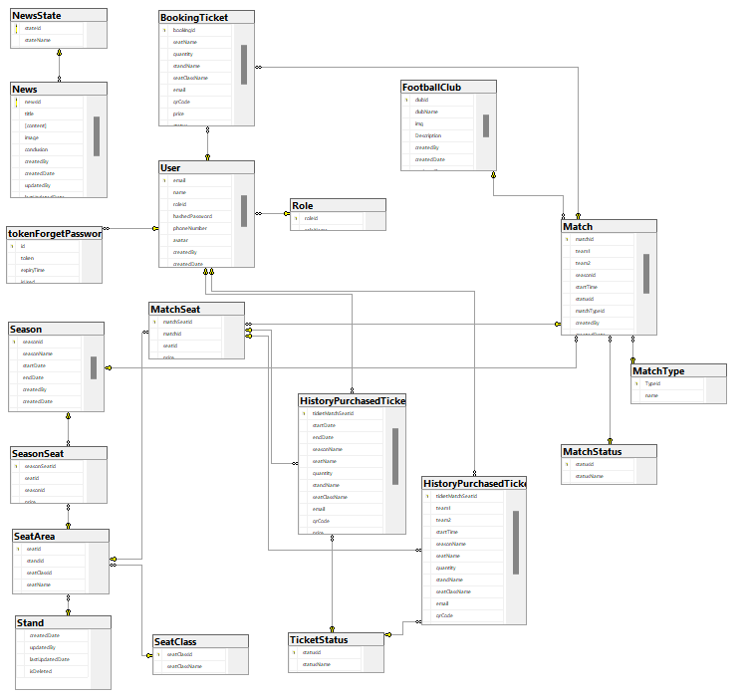

#### b. Table Descriptions

| No | Table | Description |
| --- | --- | --- |
| 01 | Role | Description: This table stores information about user roles.  Primary keys: roleId  Foreign keys: N/A |
| 02 | Football Club | Description: This table stores information about football clubs.   * Primary keys: clubId * Foreign keys: N/A |
| 03 | Stand | Description: This table stores information about stands   * Primary keys: standId * Foreign keys: N/A |
| 04 | User | Description: This table holds details about users.   * Primary keys: userId * Foreign keys: roleId (references Role(roleId)) |
| 05 | Match Status | Description: This table stores information about the status of matches.   * Primary key: statusId * Foreign keys: N/A |
| 06 | Season | Description: This table stores information about the season.   * Primary key: seasonId * Foreign keys: N/A |
| 07 | Match | Description: This table stores information about matches.   * Primary key: matchId * Foreign keys: team1 (references FootballClub(clubId)), team2 (references FootballClub(clubId)), statusId (references MatchStatus(statusId)), matchTypeId (references MatchType(TypeId)), seasonId (references Season(seasonId)) |
| 08 | News | Description: This table holds details about news.   * Primary keys: newsId * Foreign keys: stateId (references NewsState(stateId)) |
| 09 | NewsStatus | Description: This table stores information about news statuses.   * Primary keys: statusId * Foreign keys: N/A |
| 10 | NewsState | Description: This table stores information about news states.   * Primary keys: stateId * Foreign keys: N/A |
| 11 | tokenForgetPassword | Description: This table stores information about password reset tokens.   * Primary keys: id * Foreign keys: userEmail (references User(email)) |
| 12 | MatchType | Description: This table stores information about match types.   * Primary keys: TypeId * Foreign keys: N/A |
| 13 | SeatClass | Description: This table stores information about seat classes.   * Primary keys: seatClassId * Foreign keys: N/A |
| 14 | SeatArea | Description: This table stores information about seat areas.   * Primary keys: seatId * Foreign keys: standId (references Stand(standId)), seatClassId (references SeatClass(seatClassId)) |
| 15 | MatchSeat | Description: This table stores information about match seats.   * Primary keys: matchSeatId * Foreign keys: matchId (references Match(matchId)), seatId (references SeatArea(seatId)) |
| 16 | SeasonSeat | Description: This table stores information about season seats.   * Primary keys: seasonSeatId * Foreign keys: seatId (references SeatArea(seatId)), seasonId (references Season(seasonId)) |
| 17 | TicketStatus | Description: This table stores information about ticket statuses.   * Primary keys: statusId * Foreign keys: N/A |
| 18 | HistoryPurchasedTicketMatchSeat | Description: This table stores information about the history of purchased match seat tickets.   * Primary keys: ticketMatchSeatId * Foreign keys: matchSeatId (references MatchSeat(matchSeatId)), statusId (references TicketStatus(statusId)), email (references User(email)) |
| 19 | HistoryPurchasedTicketSeasonSeat | Description: This table stores information about the history of purchased season seat tickets.   * Primary keys: ticketMatchSeatId * Foreign keys: matchSeatId (references MatchSeat(matchSeatId)), statusId (references TicketStatus(statusId)), email (references User(email)) |
| 20 | BookingTicket | Description: This table stores information about booking tickets.   * Primary keys: bookingId * Foreign keys: matchId (references Match(matchId)), email (references User(email)) |

### 4.2 Code Packages

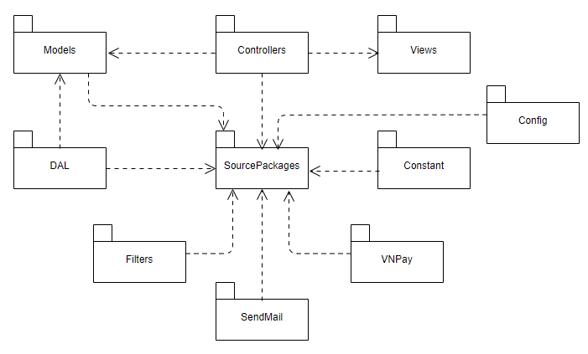

***Package descriptions***

| No | Package | Description |
| --- | --- | --- |
| 01 | models | Contains classes and logic related to data processing. Models represent the structure of data and perform necessary operations with the database |
| 02 | controllers | Holds controller files, handling user requests. Controllers manage the flow of the application, interact with Models to retrieve and update data, and pass that data to Views. |
| 03 | dal | This package contains classes and methods providing an interface to access the database. DAO separates the database access logic from the core business logic. |
| 04 | views | Contains user interface files, usually HTML. Views display data from Models and interact with users. In the MVC model, Views are not responsible for data processing. |
| 05 | SourcePackages | The central package that interacts with various other packages, coordinating the application's functionality. |
| 06 | Config | Contains configuration files necessary for the application's setup and initialization. |
| 07 | Constant | Stores constant values used throughout the application to maintain consistency and manage configurations. |
| 08 | Filters | Contains classes and methods for filtering requests and responses, typically used for authentication and authorization. |
| 09 | SendMail | Manages the functionality for sending emails, including email sending logic. |
| 10 | VNPay | Handles the integration with VNPay, managing payment processes and transactions. |

# II. Requirement Specifications

## 1. Common Functions

### 1.1 Login

#### a. UC Specification

| UC Name: | Login | | Author : Quan | | Date: 29/05/2024 | |
| --- | --- | --- | --- | --- | --- | --- |
| Primary Actor: | Customer | | Secondary Actors: | | None | |
| Trigger: | User clicks Login button from the page header, or  User accesses an authenticated feature (from a link or type the page URL directly into the address bar) | | | | | |
| Description: | As a user, I want to be able to log into the system so that I can use the system’s authenticated features and access my personalized account. | | | | | |
| Preconditions: | User account has been created & authorized | | | | | |
| Postconditions: | * User logs in the system successfully * The system tracked successful login into the Activity Log | | | | | |
| Normal Flow | **Login**  1. User accesses the User Login screen  2. User types in the login details or choo other login options (see alternative flows AF1 in the next section)  3. User clicks the Login button  4. System validates the login details (see E1)  5. System allows user to access  6. System tracks user’s success login to the Activity Log  7. System accesses the Home Page (or the previous calling page if any) | | | | | |
| Alternative Flows: | ***AF1. Google Login***  1. User chooses to login system using Google account  2. System redirects the user to the Google’s Login screen  3. User types in the Google account details and chooses to login  4. Google validates user’s login information successfully and redirect him/her back to the system  5. Return to step 5 of normal flow. | | | | | |
| Exceptions: | ***E1. System can’t authenticate the user***  1. The Error Message screen is shown to the user  2. User cancels the logging in *=> UC stops, change to other UC-View Home Page*  3. User clicks “Forgot Password?” link *=> change to the other UC-Reset Password*  4. User clicks “Register” link *=> change to other UC-Register User Account* | | | | | |
| Business Rules: | BR-01, BR-02, BR-03, BR-04, BR-06, BR-07 | | | | | |

### 1.2 Register

#### a.UC Specification

| UC Name: | Register | | Author : Quan | | Date: 29/05/2024 | |
| --- | --- | --- | --- | --- | --- | --- |
| Primary Actor: | Guest | | Secondary Actors: | | None | |
| Trigger: | User click “Create new account” from the page header, or  User accesses an authenticated feature (from a link or type the page URL directly into the address bar) | | | | | |
| Description: | As a user, I want to register an account so that I can log in to the system and be able to use its authenticated features and access my personalized account. | | | | | |
| Preconditions: | Guests need to read and accept the website's terms and conditions. | | | | | |
| Postconditions: | * The user successfully registered for an account * The system saves account information into the database | | | | | |
| Normal Flow | **Register**  1. The user accesses the User Registration screen  2. User enters registration details or selects other register options (see alternative flows AF1 in the next section)  3. The user clicks the box to agree to terms and conditions  4. Users press the Register button  5. System to authenticate registration information (see E1) | | | | | |
| Alternative Flows: | ***AF1. Google Login***  1. The user chooses to register with the system using a Google account  2. The system redirects the user to the Google account selection screen  3. User clicks "continue" to agree  4. The system redirects the user to the page to enter phone number and create a password  5. The user clicks on the box to agree to the terms and conditions  6. The user clicks on the Register box  7.Return to step 5 of normal flow. | | | | | |
| Exceptions: | ***E1. System can’t authenticate the user***  E1. The system cannot authenticate the registration  1. The Error Message screen is displayed to the user  2. User cancels registration => UC stops, switches back to UC-Register  3. User enters other correct information  4. User clicks on the “Gmail/Facebook” icon => changes to another UC-Register User Account | | | | | |
| Business Rules: | BR-05, BR-06, BR-07,BR-08, BR-09, BR-10 | | | | | |

#### 

## 2. Stand Management

### 2.1 View List Stands

#### a. UC Specifications

**Functional Description Template**

| UC Name: | View List Stands | Author: Kiet | Date: 29/05/2024 |
| --- | --- | --- | --- |
| Primary Actor: | Admin | Secondary Actors: | None |
| Trigger: | The need to view or manage stands in the system. | | |
| Description: | As an admin i want to list stands in system, so that i can manage stand | | |
| Preconditions: | The admin is authenticated and has appropriate permissions.  The system is operational and has existing stands | | |
| Postconditions: | The admin has successfully viewed or managed the stands in the system. | | |
| Normal Flow: | 1. Admin click on “Quản Lý” 2. Admin click on “Quản lý khán đài” 3. System display list of exist stands | | |
| Alternative Flows: | N/A | | |
| Exceptions: | N/A | | |
| Business Rules: | N/A | | |

### 2.2 Create Stand

#### a. UC Specifications

**Functional Description Template**

| UC Name: | Create Stand | Author: Kiet | Date: 29/05/2024 |
| --- | --- | --- | --- |
| Primary Actor: | Admin | Secondary Actors: | None |
| Trigger: | The need to create new stands in the system. | | |
| Description: | As an Admin ,I want to be able to create a new stand in the system,  So that I can manage the available stands for event organizers and attendees. | | |
| Preconditions: | The admin is authenticated and has appropriate permissions. | | |
| Postconditions: | The notification create successfully display The admin has successfully viewed new stand in list stands  Username of admin who create that stand will display in “Created By” | | |
| Normal Flow: | 1. Admin click on manage stand in manage stand 2. The modal create stand display 3. The admin fills out the required information in the form. 4. The admin clicks the "Lưu" button to create the new stand. 5. The system displays a success message to the admin, confirming the stand has been created. 6. The admin is redirected back to the "Quản Lý Khán Đài" page, where the new stand is now listed. | | |
| Alternative Flows: | 4.1 : Click on “Huỷ” in modal “Thêm Khán Đài” :   * The modal is closed * System display list existed stands | | |
| Exceptions: | 3.1 : Required Fields Validation Fail:   * If the admin does not fill out all the required fields or invalidate input in the "Thêm Khán Đài" form, the system should determine which fields are missing. * The admin should be able to correct the missing information and resubmit the form. * The system should not create the stand until all required fields are filled out correctly.   5.1 Database Error:   * If there is an error create stand attribute in the database, the system should display an error message to the admin. * The admin was notified that failed to create a stand. | | |
| Business Rules: | BR-12 | | |

### 

### 2.3 Update Stand

#### a. UC Specifications

**Functional Description Template**

| UC Name: | Update stand | Author: Kiet | Date: 29/05/2024 |
| --- | --- | --- | --- |
| Primary Actor: | Admin | Secondary Actors: | None |
| Trigger: | The need to update existed stand in the system. | | |
| Description: | As an Admin, I want to update stand so that i can modified stand information if it is not correct | | |
| Preconditions: | The admin is authenticated and has appropriate permissions.  The stand to be updated already exists in the system. | | |
| Postconditions: | The notification create successfully display The admin has successfully viewed new stand change in list stands | | |
| Normal Flow: | 1. The admin locates the stand they want to update and clicks on the icon update in ‘’Manage Stand’’ 2. This opens a modal window with the stand's current information pre-filled in the form fields. 3. The admin makes the necessary changes to the stand 4. Once the admin has made all the desired changes, they click the "Update" button. 5. The system validates the updated information and, if successful, saves the changes to the database. 6. The system displays a success message to the admin, confirming the stand has been updated. 7. The admin is redirected back to the "Manage Stand" page, where the stand is now updated. | | |
| Alternative Flows: | 4.1 : Click on “Cancel” in modal update stand :   * The modal update is closed * System display list existed stands | | |
| Exceptions: | 4.2 : Required Fields Validation Fail:   * If the admin does not fill out all the required fields or invalidate input update information in the "Update Stand" form, the system should mention which fields are missing. * The admin should be able to correct the missing information and resubmit the form. * The system should not update the stand until all required fields are filled out correctly.   5.1 Database Error:   * If there is an error updating stand attribute in the database, the system should display an error message to the admin. * The admin was notified that failed to update the stand, and they should try again or contact the system administrator. | | |
| Business Rules: | BR-12 | | |

### 2.4 Delete Stand

### a. UC Specifications

**Functional Description Template**

| UC Name: | Delete Stand | Author: Kiet | Date: 29/05/2024 |
| --- | --- | --- | --- |
| Primary Actor: | Admin | Secondary Actors: | None |
| Trigger: | The need to delete a stand in the system. | | |
| Description: | This use case involves the admin deleting stand within the system. | | |
| Preconditions: | As an Admin, I want to delete stand so that i can make the list easy to track | | |
| Postconditions: | The notification create successfully display Stand still exist in database and stand were deleted don’t display in list stands | | |
| Normal Flow: | 1. The admin locates the stand they want to delete and clicks on the recycle bin button. 2. This opens a confirmation modal window, asking the admin to confirm they want to delete the stand with id of that stand 3. The admin clicks the "OK" button to proceed with the deletion. 4. The system update attribute isDeleted of that stand to 1 in the database 5. The system displays a success message to the admin, confirming the stand has been deleted. 6. The admin is redirected back to the "Manage Stand" page, where the stand is undisplayed. | | |
| Alternative Flows: | 3.1 Cancel Deletion:   * If the admin clicks on the “Huỷ" or "X" button in the confirmation modal, the system should not proceed with the deletion. * The admin is returned to the "Manage Stands" page without any changes. | | |
| Exceptions: | 3.2 Database Error:   * If there is an error updating the isDeleted attribute in the database, the system should display an error message to the admin. * The admin should be notified that the stand deletion was not successful, and they should try again or contact the system administrator. | | |
| Business Rules: | N/A | | |

## 3. Football Club Management

### 3.1 View List Football Clubs

#### a. UC Specifications

**Functional Description Template**

| UC Name: | View List Football Clubs | Author: Kiet | Date: 14/06/2024 |
| --- | --- | --- | --- |
| Primary Actor: | Admin | Secondary Actors: | None |
| Trigger: | The need to view existing football clubs in the system. | | |
| Description: | As an admin i want to list football clubs in system, so that i can manage football clubs | | |
| Preconditions: | The admin is authenticated and has appropriate permissions.  The system is operational and has existing football clubs | | |
| Postconditions: | The admin has successfully viewed or managed the football clubs in the system. | | |
| Normal Flow: | 1. Admin click on “Quản Lý” 2. Admin click on “Quản Lý Đội Bóng” 3. System display list of existing stands | | |
| Alternative Flows: | N/A | | |
| Exceptions: | N/A | | |
| Business Rules: | N/A | | |

### 3.2 Create Football Club

#### a. UC Specifications

**Functional Description Template**

| UC Name: | Create Football Club | Author: Kiet | Date: 29/05/2024 |
| --- | --- | --- | --- |
| Primary Actor: | Admin | Secondary Actors: | None |
| Trigger: | The need to create new stands in the system. | | |
| Description: | As an Admin ,I want to be able to create a new stand in the system,  So that I can manage the available stands for event organizers and attendees. | | |
| Preconditions: | The admin is authenticated and has appropriate permissions. | | |
| Postconditions: | The notification create successfully display The admin has successfully viewed new stand in list stands  Username of admin who create that stand will display in “Created By” | | |
| Normal Flow: | 1. Admin click on “Quản Lý Đội Bóng” in “Quản Lý” 2. The modal “Thêm Đội Bóng” display 3. The admin fills out the required information in the form. 4. The admin clicks the "Lưu" button to create the new football club. 5. The system displays a success message to the admin, confirming the stand has been created. 6. The admin is redirected back to the "Quản Lý Đội Bóng" page, where the new stand is now listed. | | |
| Alternative Flows: | 4.1 : Click on “Huỷ” in modal “Thêm Đội Bóng” :   * The modal create is closed * System display list existed stands | | |
| Exceptions: | 3.1 : Required Fields Validation Fail:   * If the admin does not fill out all the required fields or invalidate input in the "Thêm Đội Bóng" form, the system should determine which fields are missing. * The admin should be able to correct the missing information and resubmit the form. * The system should not create the football club until all required fields are filled out correctly.   5.1 Database Error:   * If there is an error create stand attribute in the database, the system should display an error message to the admin. * The admin was notified that failed to create a football club. | | |
| Business Rules: | BR-11 | | |

### 

### 2.3 Update Football Club

#### a. UC Specifications

**Functional Description Template**

| UC Name: | Update Football Club | Author: Kiet | Date: 29/05/2024 |
| --- | --- | --- | --- |
| Primary Actor: | Admin | Secondary Actors: | None |
| Trigger: | The need to update existed football club in the system. | | |
| Description: | As an Admin, I want to update football club so that i can modified football club information if it is not correct | | |
| Preconditions: | The admin is authenticated and has appropriate permissions.  The stand to be updated already exists in the system. | | |
| Postconditions: | The notification create successfully display The admin has successfully viewed new football club change in list football club | | |
| Normal Flow: | 1. The admin locates the football club they want to update and clicks on the icon update 2. This opens a modal window with the club's current information pre-filled in the form fields. 3. The admin makes the necessary changes to the the football club 4. Once the admin has made all the desired changes, they click the "Lưu" button. 5. The system validates the updated information and, if successful, saves the changes to the database. 6. The system displays a success message to the admin, confirming the football club has been updated. 7. The admin is redirected back to the "Quản Lý Đội Bóng" page, where the football club is now updated. | | |
| Alternative Flows: | 4.1 : Click on “Huyr” in modal “Cập Nhật Đội Bóng” :   * The modal update is closed * System display list existed football clubs | | |
| Exceptions: | 4.2 : Required Fields Validation Fail:   * If the admin does not fill out all the required fields or invalidate input update information in the "Cập Nhật Đội Bóng" form, the system should mention which fields are missing. * The admin should be able to correct the missing information and resubmit the form. * The system should not update the foot until all required fields are filled out correctly.   5.1 Database Error:   * If there is an error updating football club attribute in the database, the system should display an error message to the admin. * The admin was notified that failed to update the football club, and they should try again or contact the system administrator. | | |
| Business Rules: | BR-11 | | |

### 2.4 Delete Football Club

### a. UC Specifications

**Functional Description Template**

| UC Name: | Delete Football Club | Author: Kiet | Date: 29/05/2024 |
| --- | --- | --- | --- |
| Primary Actor: | Admin | Secondary Actors: | None |
| Trigger: | The need to delete a football club in the system. | | |
| Description: | This use case involves the admin deleting football club within the system. | | |
| Preconditions: | As an Admin, I want to delete stand so that i can make the list easy to track | | |
| Postconditions: | The notification create successfully display Stand still exist in database and football club were deleted don’t display in list football clubs | | |
| Normal Flow: | 1. The admin locates the football clubs they want to delete and clicks on the recycle bin button. 2. This opens a confirmation modal window, asking the admin to confirm they want to delete the football club with id of that stand 3. The admin clicks the "OK" button to proceed with the deletion. 4. The system update attribute isDeleted of that football club to 1 in the database 5. The system displays a success message to the admin, confirming the football club has been deleted. 6. The admin is redirected back to the "Quản Lý Đội Bóng" page, where the football club is undisplayed. | | |
| Alternative Flows: | 3.1 Cancel Deletion:   * If the admin clicks on the “Huỷ" or "X" button in the confirmation modal, the system should not proceed with the deletion. * The admin is returned to the "Quản Lý Đội Bóng" page without any changes. | | |
| Exceptions: | 3.2 Database Error:   * If there is an error updating the isDeleted attribute in the database, the system should display an error message to the admin. * The admin should be notified that the football club deletion was not successful, and they should try again or contact the system administrator. | | |
| Business Rules: | N/A | | |

## 4. Match Management

### 4.1 View List Match

#### a. UC Specifications

**Functional Description Template**

| UC Name: | View List Match | Author: Thuat | Date: 29/05/2024 |
| --- | --- | --- | --- |
| Primary Actor: | Admin | Secondary Actors: | None |
| Trigger: | The need to view existing matches in the system. | | |
| Description: | This use case involves the admin accessing the list of matches within the system. | | |
| Preconditions: | The admin is authenticated and has appropriate permissions.  The system must have existing data for football clubs, match statuses, match types, and seasons. | | |
| Postconditions: | The admin has successfully viewed or managed the match in the system.  Match information is accurately reflected in the system. | | |
| Normal Flow: | 1. Admin click on dashboard 2. Admin click on manage the match 3. The system displays a list of existing matches | | |
| Alternative Flows: | N/A | | |
| Exceptions: | N/A | | |
| Business Rules: | N/A | | |

### 4.2 Create Match

#### a. UC Specifications

**Functional Description Template**

| UC Name: | Create Match | Author: Thuat | Date: 29/05/2024 |
| --- | --- | --- | --- |
| Primary Actor: | Admin | Secondary Actors: | None |
| Trigger: | The need to view existing football clubs in the system. | | |
| Description: | This use case involves the admin accessing the list of football clubs within the system. | | |
| Preconditions: | The admin is authenticated and has appropriate permissions.  The system must have existing data for football clubs, match statuses, match types, and seasons. | | |
| Postconditions: | The admin has successfully viewed or managed the match in the system.  Match information is accurately reflected in the system. | | |
| Normal Flow: | 1. Admin click on dashboard 2. Admin click on manage the match 3. The system displays a list of existing matches | | |
| Alternative Flows: | 1. Admin click on Create Match in “Manage Match” page 2. The modal creates match display 3. The admin fills out the required information in the form. 4. The admin clicks the "Create" button to create the new match. 5. The system displays a success message to the admin, confirming the match has been created. 6. The admin is redirected back to the "Manage Match" page, where the new stand is now listed. | | |
| Exceptions: | 4.1: Click on “Cancel” in modal create match :   * The modal update is closed. * The system displays a list of existing matches. | | |
| Business Rules: | BR-13, BR-14 | | |

### 4.3 Delete Match

#### a. UC Specifications

**Functional Description Template**

| UC Name: | Delete Match | Author: Thuat | Date: 29/05/2024 |
| --- | --- | --- | --- |
| Primary Actor: | Admin | Secondary Actors: | None |
| Trigger: | The need to delete Match in the system. | | |
| Description: | This use case involves the admin deleting the match within the system. | | |
| Preconditions: | As an Admin, I want to delete the match so that I can make the list very clean. | | |
| Postconditions: | The notification Delete successfully displays. The match still exists in the database and the match that was deleted doesn’t display in the list of matches. | | |
| Normal Flow: | 1. The admin locates the match they want to delete and clicks on the recycle bin button. 2. This opens a confirmation modal window, asking the admin to confirm they want to delete the match with the id of that match. 3. The admin clicks the "OK" button to proceed with the deletion. 4. The system update attribute isDeleted of that match to 1 in the database. 5. The system displays a success message to the admin, confirming the match has been deleted. 6. The admin is redirected back to the "Manage Match" page, where the match is undisplayed. | | |
| Alternative Flows: | 3.1 Cancel Deletion:   * If the admin clicks on the "Cancel" or "X" or outside pop-up button in the confirmation modal, the system should not proceed with the deletion. * The admin is returned to the "Manage Match" page without any changes. | | |
| Exceptions: | 3.2 Database Error:   * If there is an error updating the isDeleted attribute in the database, the system should display an error message to the admin. * The admin should be notified that the match deletion was not successful, and they should try again or contact the system administrator. | | |
| Business Rules: | BR-16 | | |

### 4.4 Update Match

#### a. UC Specifications

**Functional Description Template**

| UC Name: | Update Match | Author: Thuat | Date: 27/07/2024 |
| --- | --- | --- | --- |
| Primary Actor: | Admin | Secondary Actors: | None |
| Trigger: | The need to update Match in the system. | | |
| Description: | This use case involves the admin deleting the match within the system. | | |
| Preconditions: | As an Admin, I want to update the match so that I can make the list very clean. | | |
| Postconditions: | The notification Update successfully displays. The match still exists in the database and the match is in a scheduled or selling state. | | |
| Normal Flow: | 1. The admin locates the match they want to update and clicks on the eye button.. 2. The popup screen will display full match information, the admin edits the necessary information. 3. The admin clicks the "Lưu" button to proceed with the updation. 4. The admin is redirected back to the "Manage Match" page, where the match is updated. | | |
| Alternative Flows: | 3.1 Cancel Updation:   * If the admin clicks on the "Huỷ" or "X" or outside pop-up button in the popup modal, the system should not proceed with the updation. * The admin is returned to the "Manage Match" page without any changes. | | |
|  |  | | |
| Business Rules: | BR-13, BR-16 | | |

## 5. User Management

### 5.1 View List User

#### a. UC Specifications

**Functional Description Template**

| UC Name: | View List User | Author: Vinh | Date:30/05/2024 |
| --- | --- | --- | --- |
| Primary Actor: | Admin | Secondary Actors: | None |
| Trigger: | The admin needs to view a list of users within the system.  This could be triggered from an "Admin Dashboard" or a dedicated "User Management" section. | | |
| Description: | As an administrator, I want to view a list of all users registered in the system. This will allow me to manage users | | |
| Preconditions: | The admin is authenticated and logged in to the system.  The admin has the necessary permissions to view user information("View Users" permission).  The system is operational. | | |
| Postconditions: | The admin has successfully viewed or managed the user in the system. | | |
| Normal Flow: | **View List User**   1. Admin click on dashboard 2. Admin click on manage user 3. System display list of existing users | | |
| Alternative Flows: | N/A | | |
| Exceptions: | N/A | | |
| Business Rules: | N/A | | |

### 5.2 Search User

#### a. UC Specifications

**Functional Description Template**

| UC Name: | Search User | Author: Vinh | Date:30/05/2024 |
| --- | --- | --- | --- |
| Primary Actor: | Admin | Secondary Actors: | None |
| Trigger: | The admin needs to find a specific user within the system.  This could be triggered from a dedicated "Search User" function or from the "View List of Users" page. | | |
| Description: | As an administrator, I want to search for a specific user registered in the system. This will allow me to quickly locate a user's profile, manage their account, or investigate any issues related to their activity. | | |
| Preconditions: | The admin is authenticated and logged in to the system.  The admin has the necessary permissions to view user information.  The system is operational. | | |
| Postconditions: | The admin successfully searches for the specified user.  The system displays the user's profile information or redirects the admin to the appropriate user management page.. | | |
| Normal Flow: | **Search User**  Admin click on dashboard  Admin click on manage user  System display list of existing users  Admin Selects Search Criteria:  The system presents a search form or interface.  The admin enters the search query for the selected criteria.  System Displays Search Results:   * 1. If a single matching user is found, the system displays the user's profile information or redirects the admin to the appropriate user management page.   2. If multiple matching users are found, the system displays a list of results, allowing the admin to select the specific user they are looking for. | | |
| Alternative Flows: | **No User Found:**   1. If the system cannot find any users matching the search criteria, the system displays an appropriate message informing the admin ( "No Users Found"). | | |
| Exceptions: | N/A | | |
| Business Rules: | N/A | | |

### 5.3 Create User

#### a. UC Specifications

**Functional Description Template**

| UC Name: | Create User | Author: Vinh | Date:30/05/2024 |
| --- | --- | --- | --- |
| Primary Actor: | Admin | Secondary Actors: | None |
| Trigger: | The admin needs to view a list of users within the system.  This could be triggered from an "Admin Dashboard" or a dedicated "User Management" section. | | |
| Description: | As an administrator, I want to create users in the system. This will allow me to quickly locate a user's profile, manage their account, or investigate any issues related to their activity. | | |
| Preconditions: | The admin is authenticated and logged in to the system.  The admin has the necessary permissions to view user information.  The system is operational. | | |
| Postconditions: | The admin successfully created a user.  The system displays the user's profile information or redirects the admin to the appropriate user management page.. | | |
| Normal Flow: | **Create User**   1. Admin Clicks on Dashboard: The admin logs in and clicks on the "Dashboard" link from the navigation menu. 2. Admin Clicks on Manage Users: From the dashboard, the admin selects the "Manage Users" option. 3. System Displays List of Existing Users: The system displays a list of all existing users in the system. 4. Admin Clicks on Create User: The admin clicks the "Create User" button to initiate the user creation process. 5. System Displays User Creation Form: The system presents a form for entering new user details (e.g., name, email, role, etc.). 6. Admin Enters User Details: The admin fills out the user creation form with the required details. 7. Admin Submits the Form: The admin clicks the "Submit" or "Save" button to create the new user. 8. System Validates Input: The system validates the input data (e.g., required fields, email format, etc.). 9. System Creates User: If validation is successful, the system creates the new user and saves the details to the database. 10. System Displays Confirmation Message: The system displays a confirmation message indicating that the user has been created successfully. 11. System Redirects to User List: The system redirects the admin back to the list of existing users or the relevant user management page. | | |
| Alternative Flows: | **1. Validation Errors:**   1. Admin Enters User Details: The admin fills out the user creation form with details. 2. Admin Submits the Form: The admin clicks the "Submit" or "Save" button. 3. System Validates Input: The system detects validation errors (e.g., missing required fields, invalid email format). 4. System Displays Error Messages: The system displays appropriate error messages indicating what needs to be corrected. 5. Admin Corrects Input: The admin corrects the errors based on the provided messages. 6. Admin Resubmits the Form: The admin resubmits the form after correcting the errors. 7. System Repeats Validation and Creation Steps: The system validates the corrected input and, if successful, creates the user as described in the normal flow.   **2. User Creation Failure:**   1. Admin Submits the Form: The admin submits the form. 2. System Validates Input: The system performs validation. 3. System Encounters a Problem Creating User: If there’s an issue creating the user (e.g., database error, server issue), the system cannot save the new user. 4. System Displays Error Message: The system displays an error message indicating the failure to create the user. 5. Admin Reattempts Creation: The admin may try to create the user again or contact support for assistance.   **3. User Already Exists:**   1. Admin Enters User Details: The admin fills out the form. 2. Admin Submits the Form: The admin submits the form. 3. System Checks for Existing Users: The system checks if a user with the same email or username already exists. 4. System Finds Existing User: If an existing user is found, the system displays an error message indicating that a user with that email/username already exists. 5. Admin Revises Details: The admin revises the details and resubmits the form with unique information. 6. System Repeats Validation and Creation Steps: The system validates the new details and, if successful, creates the user. | | |
| Exceptions: | N/A | | |
| Business Rules: | BR-17 | | |

### 5.4 Update User

#### a. UC Specifications

**Functional Description Template**

| UC Name: | Update User | Author: Vinh | Date:30/05/2024 |
| --- | --- | --- | --- |
| Primary Actor: | Admin | Secondary Actors: | None |
| Trigger: | The admin needs to view a list of users within the system.  This could be triggered from an "Admin Dashboard" or a dedicated "User Management" section. | | |
| Description: | As an administrator, I want to update user details in the system. This will allow me to modify user information, manage their accounts, or correct any issues related to their activity. | | |
| Preconditions: | The admin is authenticated and logged in to the system.  The admin has the necessary permissions to view user information.  The system is operational. | | |
| Postconditions: | The admin successfully updates the user’s details.  The system reflects the updated user information in the user profile or management page. | | |
| Normal Flow: | **Update User**   1. Admin Clicks on Dashboard: The admin logs in and clicks on the "Dashboard" link from the navigation menu. 2. Admin Clicks on Manage Users: From the dashboard, the admin selects the "Manage Users" option. 3. System Displays List of Existing Users: The system displays a list of all existing users in the system. 4. Admin Selects a User to Update: The admin selects the user whose details need to be updated from the list. 5. System Displays User Details: The system displays the selected user's current details in an editable form. 6. Admin Updates User Details: The admin modifies the user details as needed (e.g., name, email, role, etc.). 7. Admin Submits the Form: The admin clicks the "Submit" or "Save" button to update the user’s details. 8. System Validates Input: The system validates the updated data (e.g., required fields, email format, etc.). 9. System Updates User: If validation is successful, the system updates the user’s information in the database. 10. System Displays Confirmation Message: The system displays a confirmation message indicating that the user details have been successfully updated. 11. System Redirects to User List or Profile: The system redirects the admin back to the list of existing users or the updated user’s profile page. | | |
| Alternative Flows: | **1. Validation Errors:**   1. Admin Updates User Details: The admin modifies the user details. 2. Admin Submits the Form: The admin clicks the "Submit" or "Save" button. 3. System Validates Input: The system detects validation errors (e.g., missing required fields, invalid email format). 4. System Displays Error Messages: The system displays appropriate error messages indicating what needs to be corrected. 5. Admin Corrects Input: The admin corrects the errors based on the provided messages. 6. Admin Resubmits the Form: The admin resubmits the form after correcting the errors. 7. System Repeats Validation and Update Steps: The system validates the corrected input and, if successful, updates the user as described in the normal flow.   **2. User Update Failure:**   1. Admin Submits the Form: The admin submits the form. 2. System Validates Input: The system performs validation. 3. System Encounters a Problem Updating User: If there’s an issue updating the user (e.g., database error, server issue), the system cannot save the updated information. 4. System Displays Error Message: The system displays an error message indicating the failure to update the user. 5. Admin Reattempts Update: The admin may try to update the user again or contact support for assistance.   **3. User Not Found:**   1. Admin Selects a User to Update: The admin selects a user to update from the list. 2. System Displays User Details: The system attempts to display the user’s details but fails to find the user. 3. System Displays Error Message: The system displays an error message indicating that the user was not found. 4. Admin Reattempts Selection: The admin may retry selecting the user or refresh the list of users. | | |
| Exceptions: | N/A | | |
| Business Rules: | BR-17 | | |

### 5.5 Change status user

#### a. UC Specifications

**Functional Description Template**

| UC Name: | Change status user | Author: Vinh | Date:30/05/2024 |
| --- | --- | --- | --- |
| Primary Actor: | Admin | Secondary Actors: | None |
| Trigger: | The admin needs to view a list of users within the system.  This could be triggered from an "Admin Dashboard" or a dedicated "User Management" section. | | |
| Description: | As an administrator, I want to change the status of a user in the system. This will allow me to activate, deactivate, or otherwise update the status of a user’s account as needed. | | |
| Preconditions: | The admin is authenticated and logged in to the system.  The admin has the necessary permissions to view user information.  The system is operational. | | |
| Postconditions: | The admin successfully changes the user’s status. - The system reflects the updated status of the user in the user profile or management page. | | |
| Normal Flow: | **Change Status User**   1. Admin Clicks on Dashboard: The admin logs in and clicks on the "Dashboard" link from the navigation menu. 2. Admin Clicks on Manage Users: From the dashboard, the admin selects the "Manage Users" option. 3. System Displays List of Existing Users: The system displays a list of all existing users in the system. 4. Admin Selects a User to Change Status: The admin selects the user whose status needs to be changed from the list. 5. System Displays User Details: The system displays the selected user's current details along with the current status. 6. Admin Chooses New Status: The admin selects the new status for the user (e.g., Active, Inactive, Suspended) from a dropdown or other selection method. 7. Admin Submits Status Change: The admin clicks the "Update Status" or "Save" button to apply the new status. 8. System Validates Input: The system validates the new status selection to ensure it’s a valid option. 9. System Updates User Status: If validation is successful, the system updates the user’s status in the database. 10. System Displays Confirmation Message: The system displays a confirmation message indicating that the user status has been successfully updated. 11. System Redirects to User List or Profile: The system redirects the admin back to the list of existing users or the updated user’s profile page. | | |
| Alternative Flows: | **1. Invalid Status Selection:**   1. Admin Chooses New Status: The admin selects a new status for the user. 2. Admin Submits Status Change: The admin clicks the "Update Status" or "Save" button. 3. System Validates Input: The system detects that the selected status is invalid or not allowed. 4. System Displays Error Message: The system displays an error message indicating that the status selection is invalid. 5. Admin Revises Status: The admin selects a valid status and resubmits the status change. 6. System Repeats Validation and Update Steps: The system validates the revised status and, if valid, updates the user status as described in the normal flow.   **2. User Update Failure:**   1. Admin Submits Status Change: The admin submits the form. 2. System Validates Input: The system performs validation. 3. System Encounters a Problem Changing Status: If there’s an issue updating the status (e.g., database error, server issue), the system cannot save the updated status. 4. System Displays Error Message: The system displays an error message indicating the failure to change the user status. 5. Admin Reattempts Status Change: The admin may try to change the status again or contact support for assistance.   **3.User Not Found**:   1. Admin Selects a User to Change Status: The admin selects a user to change status from the list. 2. System Displays User Details: The system attempts to display the user’s details but fails to find the user. 3. System Displays Error Message: The system displays an error message indicating that the user was not found. 4. Admin Reattempts Selection: The admin may retry selecting the user or refresh the list of users. | | |
| Exceptions: | N/A | | |
| Business Rules: | N/A | | |

## 6. Season Management

### 6.1 View List Season

#### a. UC Specifications

**Functional Description Template**

| UC Name: | View List Season | Author: Vinh | Date:30/05/2024 |
| --- | --- | --- | --- |
| Primary Actor: | Admin | Secondary Actors: | None |
| Trigger: | The admin needs to view a list of seasons within the system.  This could be triggered from an "Admin Dashboard" or a dedicated "Season Management" section. | | |
| Description: | As an administrator (or authorized user with permission), I want to view a list of all seasons defined in the system. This will allow me to manage seasons | | |
| Preconditions: | The admin is authenticated and logged in to the system.  The admin has the necessary permissions to view season information("View Seasons" permission).  The system is operational. | | |
| Postconditions: | The admin has successfully viewed or managed the season in the system. | | |
| Normal Flow: | **View List Season**   1. Admin click on dashboard 2. Admin click on manage season 3. System display list of existing seasons | | |
| Alternative Flows: | **No Seasons Found:**   1. If there are no seasons defined in the system, the system displays an appropriate message informing the user (e.g., "No Seasons Found"). | | |
| Exceptions: | N/A | | |
| Business Rules: | N/A | | |

### 6.2 Create Season

#### a. UC Specifications

**Functional Description Template**

| UC Name: | Create Season | Author: Vinh | Date:30/05/2024 |
| --- | --- | --- | --- |
| Primary Actor: | Admin | Secondary Actors: | None |
| Trigger: | The admin needs to create a season within the system.  This could be triggered from an "Admin Dashboard" or a dedicated "Season Management" section. | | |
| Description: | As an administrator (or authorized user with permission), I want to create seasons in the system. This will allow me to manage seasons | | |
| Preconditions: | The admin is authenticated and logged in to the system.  The admin has the necessary permissions to create a season information("Create Seasons" permission).  The system is operational. | | |
| Postconditions: | The admin has successfully created or managed the season in the system. | | |
| Normal Flow: | **Create Season**   1. Admin click on dashboard 2. Admin click on manage season 3. System display list of existing seasons 4. Admin click on Create Season button 5. FIll all the field input in the pop up create season 6. Click Create button to finish 7. System display message create season successfully | | |
| Alternative Flows: | **Fields input when create is Invalid:**   1. Admin click on dashboard 2. Admin click on manage season 3. System display list of existing seasons 4. Admin click on Create Season button 5. Cannot fill all the field input 6. System check valid and display message all the fields have required 7. Fill all input 8. Click Create button to finish 9. System display message create season successfully | | |
| Exceptions: | N/A | | |
| Business Rules: | BR-21 | | |

### 6.3 Update Season

#### a. UC Specifications

**Functional Description Template**

| UC Name: | Update Season | Author: Vinh | Date:30/05/2024 |
| --- | --- | --- | --- |
| Primary Actor: | Admin | Secondary Actors: | None |
| Trigger: | The admin needs to update a season within the system.  This could be triggered from an "Admin Dashboard" or a dedicated "Season Management" section. | | |
| Description: | As an administrator (or authorized user with permission), I want to update seasons in the system. This will allow me to manage seasons | | |
| Preconditions: | The admin is authenticated and logged in to the system.  The admin has the necessary permissions to update a season information("Update Seasons" permission).  The system is operational. | | |
| Postconditions: | The admin has successfully updated or managed the season in the system. | | |
| Normal Flow: | **Update Season**   1. Admin click on dashboard 2. Admin click on manage season 3. System display list of existing seasons 4. Admin click on Update Season icon 5. FIll all the field input in the pop up update season want update with valid 6. Click Save button to finish 7. System display message update season successfully | | |
| Alternative Flows: | **Fields input when update is Invalid:**   1. Admin click on dashboard 2. Admin click on manage season 3. System display list of existing seasons 4. Admin click on Update Season icon 5. Fill all the field input want to update with invalid input 6. System check valid and display message error 7. Fill all input with valid 8. Click Save button to finish 9. System display message update season successfully | | |
| Exceptions: | N/A | | |
| Business Rules: | BR-21 | | |

### 6.4 Delete Season

#### a. UC Specifications

**Functional Description Template**

| UC Name: | Delete Season | Author: Vinh | Date:30/05/2024 |
| --- | --- | --- | --- |
| Primary Actor: | Admin | Secondary Actors: | None |
| Trigger: | The admin needs to delete a season within the system.  This could be triggered from an "Admin Dashboard" or a dedicated "Season Management" section. | | |
| Description: | As an administrator (or authorized user with permission), I want to delete seasons in the system. This will allow me to manage seasons | | |
| Preconditions: | The admin is authenticated and logged in to the system.  The admin has the necessary permissions to delete a season information("Delete Seasons" permission).  The system is operational. | | |
| Postconditions: | The admin has successfully updated or managed the season in the system. | | |
| Normal Flow: | **Delete Season**   1. Admin click on dashboard 2. Admin click on manage season 3. System display list of existing seasons 4. Admin click on Delete Season icon 5. Message to confirm delete is display 6. Click Yes to confirm 7. System display message delete season successfully | | |
| Alternative Flows: | **Cannot confirm :**   1. Admin click on dashboard 2. Admin click on manage season 3. System display list of existing seasons 4. Admin click on Delete Season icon 5. Message to confirm delete is display 6. Click Cancel 7. Admin click on Delete Season icon 8. Message to confirm delete is display 9. Click Yes to confirm 10. System display message update season successfully | | |
| Exceptions: | N/A | | |
| Business Rules: | BR-21 | | |

## 7. News Management

### 7.1 View List news

#### a. UC Specifications

**Functional Description Template**

| UC Name: | View List News | Author : Duong | Date: 30/05/2024 |
| --- | --- | --- | --- |
| Primary Actor: | Admin | Secondary Actors: | None |
| Trigger: | - The need to view or manage news in the system. | | |
| Description: | - As an admin i want to list news in system, so that i can manage news | | |
| Preconditions: | - The admin is authenticated and has appropriate permissions.  - The system is operational and has existing news | | |
| Postconditions: | - The admin has successfully viewed or managed the news in the system. | | |
| Normal Flow: | 1. Admin click on dashboard 2. Admin click on manage news 3. System display list of exist news | | |
| Alternative Flows: | N/A | | |
| Exceptions: | N/A | | |
| Business Rules: | N/A | | |

### 7.2 Create news

#### a. UC Specifications

**Functional Description Template**

| UC Name: | Create news | Author : Duong | Date: 30/05/2024 |
| --- | --- | --- | --- |
| Primary Actor: | Admin | Secondary Actors: | None |
| Trigger: | - The need to create new news in the system. | | |
| Description: | - As an Admin ,I want to be able to create a new news in the system,  - So that I can manage the available news for event organizers and attendees. | | |
| Preconditions: | - The admin is authenticated and has appropriate permissions. | | |
| Postconditions: | - The notification create successfully display - The admin has successfully viewed new news in list stands  - Username of admin who create that news will display in “Created By” | | |
| Normal Flow: | 1. Admin click on manage news in manage news 2. The modal create news display 3. The admin fills out the required information in the form. 4. The admin clicks the "Create" button to create the new news . 5. The system displays a success message to the admin, confirming the news has been created. 6. The admin is redirected back to the "Manage news " page, where the new news is now listed. | | |
| Alternative Flows: | - Click on “Cancel” in modal create news :   * The modal update is closed * System display list existed news | | |
| Exceptions: | - Required Fields Validation Fail:   * If the admin does not fill out all the required fields or invalidate input in the "Create news " form, the system should determine which fields are missing. * The admin should be able to correct the missing information and resubmit the form. * The system should not create the news until all required fields are filled out correctly.   - Database Error:   * If there is an error created news attribute in the database, the system should display an error message to the admin. * The admin should be notified that failed to create a news . | | |
| Business Rules: | BR-18 | | |

### 7.3 Update news

#### a. UC Specifications

**Functional Description Template**

| UC Name: | Update news | Author : Duong | Date: 30/05/2024 |
| --- | --- | --- | --- |
| Primary Actor: | Admin | Secondary Actors: | None |
| Trigger: | - The need to update existing news in the system. | | |
| Description: | - As an Admin, I want to update news so that i can modified stand information if it is not correct | | |
| Preconditions: | - The admin is authenticated and has appropriate permissions.  - The news to be updated already exists in the system. | | |
| Postconditions: | - The notification create successfully display - The admin has successfully viewed new news change in list news  - Username of admin who update that news will display in “Last Updated By” | | |
| Normal Flow: | 1. The admin locates the stand they want to update and clicks on the icon update in ‘’Manage news 2. This opens a modal window with the news’s current information pre-filled in the form fields. 3. The admin makes the necessary changes to the news 4. Once the admin has made all the desired changes, they click the "Update" button. 5. The system validates the updated information and, if successful, saves the changes to the database. 6. The system displays a success message to the admin, confirming the news has been updated. 7. The admin is redirected back to the "Manage news " page, where the news is now updated. | | |
| Alternative Flows: | 4.1 : Click on “Cancel” in modal update news :   * The modal update is closed * System display list existed news | | |
| Exceptions: | 4.2 : Required Fields Validation Fail:   * If the admin does not fill out all the required fields or invalidate input update information in the "Update news " form, the system should mention which fields are missing. * The admin should be able to correct the missing information and resubmit the form. * The system should not update the news until all required fields are filled out correctly.   5.1 Database Error:   * If there is an error updating news attribute in the database, the system should display an error message to the admin. * The admin should be notified that failed to update news , and they should try again or contact the system administrator. | | |
| Business Rules: | BR-18 | | |

### 7.4 Delete news

### a. UC Specifications

**Functional Description Template**

| UC Name: | Delete news | Author : Duong | Date: 30/05/2024 |
| --- | --- | --- | --- |
| Primary Actor: | Admin | Secondary Actors: | None |
| Trigger: | - The need to delete news in the system. | | |
| Description: | - This use case involves the admin deleting news within the system. | | |
| Preconditions: | - As an Admin, I want to delete news so that i can make the list easy to track | | |
| Postconditions: | - The notification create successfully display - News still exist in database and news were deleted don’t display in list News | | |
| Normal Flow: | 1. The admin locates the news they want to delete and clicks on the recycle bin button. 2. This opens a confirmation modal window, asking the admin to confirm they want to delete the news with id of that stand 3. The admin clicks the "OK" button to proceed with the deletion. 4. The system update attribute isDeleted of that news to 1 in the database 5. The system displays a success message to the admin, confirming the news has been deleted. 6. The admin is redirected back to the "Manage news " page, where the news is undisplayed. | | |
| Alternative Flows: | 3.1 Cancel Deletion:   * If the admin clicks on the "Cancel" or "X" button in the confirmation modal, the system should not proceed with the deletion. * The admin is returned to the "Manage news " page without any changes. | | |
| Exceptions: | 3.2 Database Error:   * If there is an error updating the isDeleted attribute in the database, the system should display an error message to the admin. * The admin should be notified that the news deletion was not successful, and they should try again or contact the system administrator. | | |
| Business Rules: | N/A | | |

### 7.5. View News Details

#### a. UC Specifications

**Functional Description Template**

| UC Name: | View News Details | Author : Duong | Date: 30/05/2024 |
| --- | --- | --- | --- |
| Primary Actor: | Admin | Secondary Actors: | None |
| Trigger: | - The need to view news details in the system. | | |
| Description: | - As an admin i want to list news details in system, so that i can see more details about news | | |
| Preconditions: | - The admin is authenticated and has appropriate permissions.  - The system is operational and has existing news | | |
| Postconditions: | - The admin has successfully viewed or managed the detailed news in the system. | | |
| Normal Flow: | 1. Admin click on dashboard 2. Admin click on manage news 3. Admin click on icon show details news 4. System display details of news | | |
| Alternative Flows: | N/A | | |
| Exceptions: | N/A | | |
| Business Rules: | N/A | | |

## 8. History Purchased Ticket Management

### 8.1 View List Ticket Match Seat

#### a. UC Specifications

**Functional Description Template**

| UC Name: | View List Ticket Match Seat | Author : Duong | Date: 30/05/2024 |
| --- | --- | --- | --- |
| Primary Actor: | Admin | Secondary Actors: | None |
| Trigger: | -N/A | | |
| Description: | - As an admin i want to list tickets match seat in system, so that i can manage tickets | | |
| Preconditions: | - The admin is authenticated and has appropriate permissions.  - The system is operational and has existing ticket match seat | | |
| Postconditions: | - The admin has successfully viewed or managed the ticket match seat in the system. | | |
| Normal Flow: | 1. Admin click on dashboard 2. Admin click on manage ticket match seat 3. System display list of exist ticket match seat | | |
| Alternative Flows: | N/A | | |
| Exceptions: | N/A | | |
| Business Rules: | N/A | | |

### 8.2 View List Ticket Season Seat

#### a. UC Specifications

**Functional Description Template**

| UC Name: | View List Ticket Season Seat | Author : Duong | Date: 30/05/2024 |
| --- | --- | --- | --- |
| Primary Actor: | Admin | Secondary Actors: | None |
| Trigger: | -N/A | | |
| Description: | - As an admin i want to list tickets season seat in system, so that i can manage tickets | | |
| Preconditions: | - The admin is authenticated and has appropriate permissions.  - The system is operational and has existing ticket season seat | | |
| Postconditions: | - The admin has successfully viewed or managed the ticket season seat in the system. | | |
| Normal Flow: | 1. Admin click on dashboard 2. Admin click on manage ticket season seat 3. System display list of exist ticket season seat | | |
| Alternative Flows: | N/A | | |
| Exceptions: | N/A | | |
| Business Rules: | N/A | | |

## 9. User Access

### 9.1 View My Tickets

#### a. UC Specifications

**Functional Description Template**

| UC Name: | View My Tickets | Author : Kiet | Date:20 /06/2024 |
| --- | --- | --- | --- |
| Primary Actor: | Customer | Secondary Actors: | None |
| Trigger: | - Customer want to view history purchased ticket | | |
| Description: | - As a customer i want to view my tickets history so that i can know what ticket i have buyed and show it to ticket inspector | | |
| Preconditions: | - Customer login the system successfully | | |
| Postconditions: | - Customer can view tickets and ticket detail that contain qr code | | |
| Normal Flow: | 1. Customer choose “Vé đã mua” in drop down menu “Tài khoản” 2. System display tickets that haven’t scanned yet of customer 3. Customer click on a ticket 4. System display detail information of ticket include qr code | | |
| Alternative Flows: | 3.1: Customer filter ticket by status:   * Customer choose “Đã quét” * System display tickets that customer had used   3.2: Customer filter ticket by status:   * Customer choose “Hết hiệu lực” * System display tickets that haven’t scanned yet and the match is end   3.3: Customer filter ticket by date:   * Customer choose start date and end date * System display tickets between date that customer choosed | | |
| Exceptions: | N/A | | |
| Business Rules: | BR-19, BR-20 | | |

# 

## 10. Management

### 10.1 Dashboard

#### a. UC Specifications

**Functional Description Template**

| UC Name: | Dashboard | Author : Kiet | Date:20 /06/2024 |
| --- | --- | --- | --- |
| Primary Actor: | Admin | Secondary Actors: | None |
| Trigger: | - Admin want to see statistical of system | | |
| Description: | - As an admin I want to view a dashboard overview, so that I can quickly understand the overall performance and key metrics of ticket sales | | |
| Preconditions: | - The admin is authenticated and has appropriate permissions. | | |
| Postconditions: | - Dash board display tickets, revenue in diagram correctly base on information in database | | |
| Normal Flow: | 1. Customer choose “Thống Kê” 2. System display | | |
| Alternative Flows: | N/A | | |
| Exceptions: | N/A | | |
| Business Rules: | N/A | | |

# 

# III. Screen Designs

## 1. User Access

### 1.1 User Login

This screen allows users to log into the system.

#### UI Design

**S1_User Login screen**

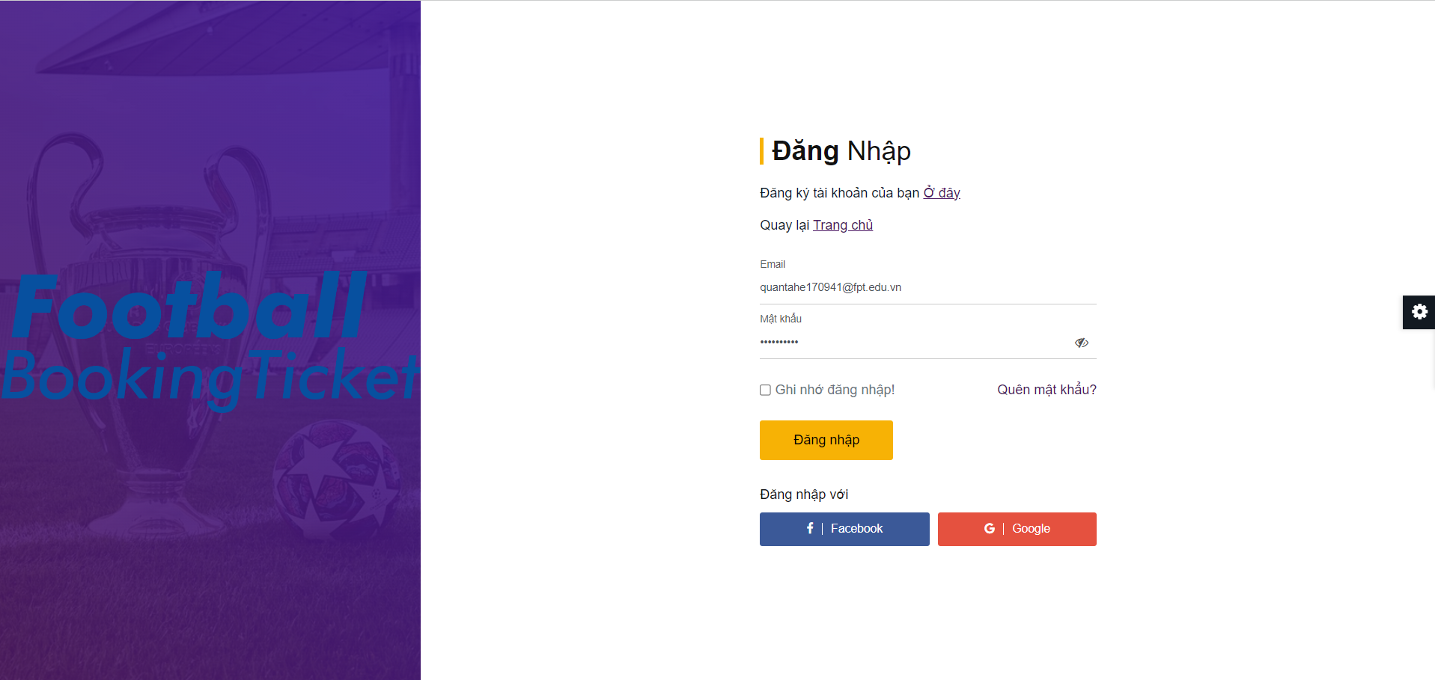

**S2_Select account to login (with Google)**

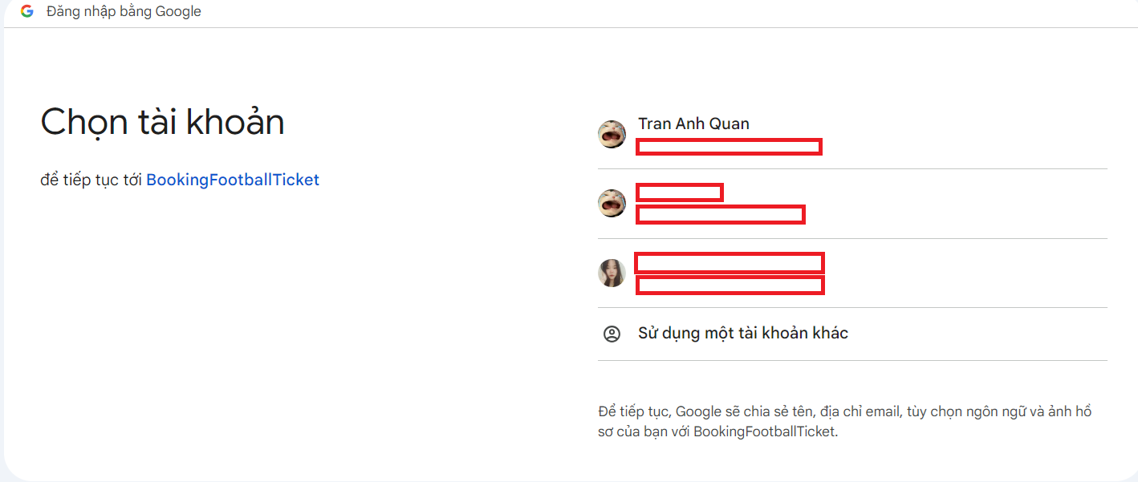

| **Field Name** | **Field Type** | **Description** |
| --- | --- | --- |
| Email* | String(50) | This is for user to input valid email address/username for logging in |
| Password* | String(100) | This is for user to input password for logging in |
| Eye icon | Button | This allows the user to show or hide the password |
| Remember me | Box | Check the box to remember login |
| Login | Button | User clicks to authenticate him/herself into the system with provided email & password |
| Create new account | Hyperlink | User clicks to redirect to the User Register page for registering new user account to access the system |
| Forgot Password? | Hyperlink | User clicks to redirect to the Password Reset page for resetting his/her forgot password |
| Login with Google | Hyperlink | Allow user to login with his/her Google account |
| Login with Facebook | Hyperlink | Allow user to login with his/her Facebook account |

#### Database Access

| **Table** | **CRUD** | **Description** |
| --- | --- | --- |
| User | R | Verify Gmail & Password information |

#### 

### 1.2 Password Change

This screen allows users to change their account password.

#### UI Design

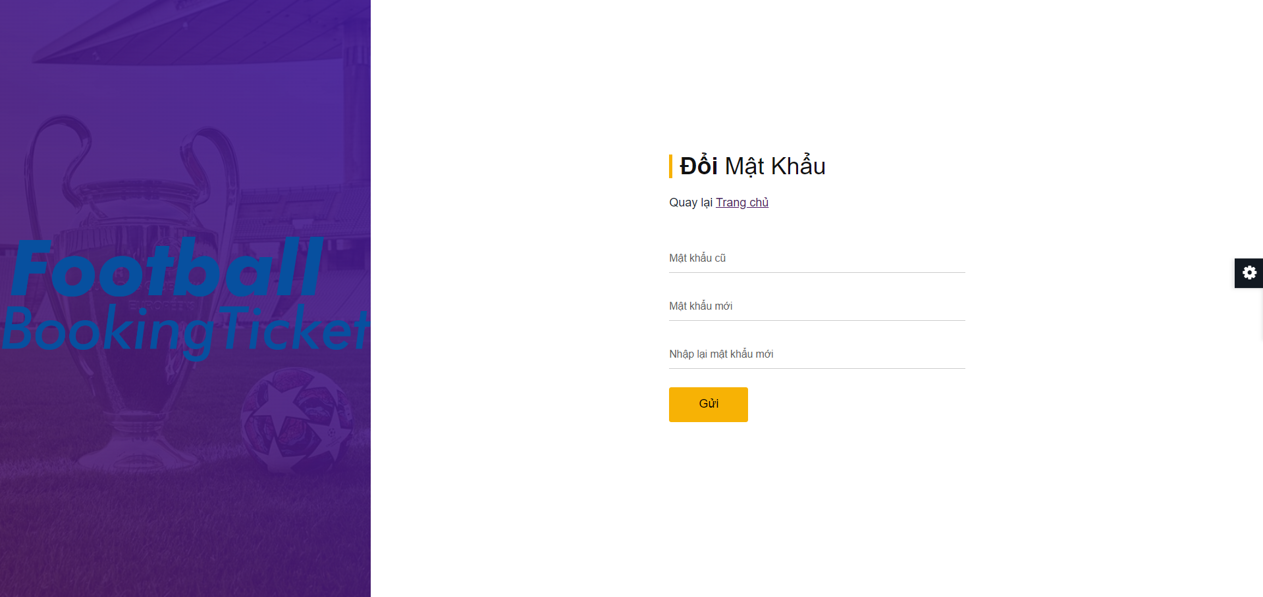

| **Field Name** | **Field Type** | **Description** |
| --- | --- | --- |
| Old Password* | String(100) | User enters old password |
| New Password* | String(100) | User enters new password |
| Confirm Password* | String(100) | User enters confirm new password |
| Submit | Button | The user presses submit to change the new password |

#### Database Access

| **Table** | **CRUD** | **Description** |
| --- | --- | --- |
| User | U | Update new password |

## 

### 1.3 Logout

At the Home Page screen, the user points to Profile and clicks "Logout" to log out of the account from the system.

#### UI Design

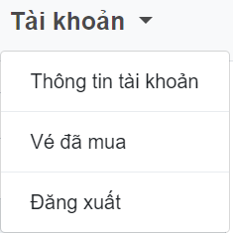

| **Field Name** | **Field Type** | **Description** |
| --- | --- | --- |
| Logout | Button | Log out of the account from the system. |

## 

### 1.4 Password Reset

This screen allows users to reset their account password.

#### UI Design

**S1_User Enter Their Email**

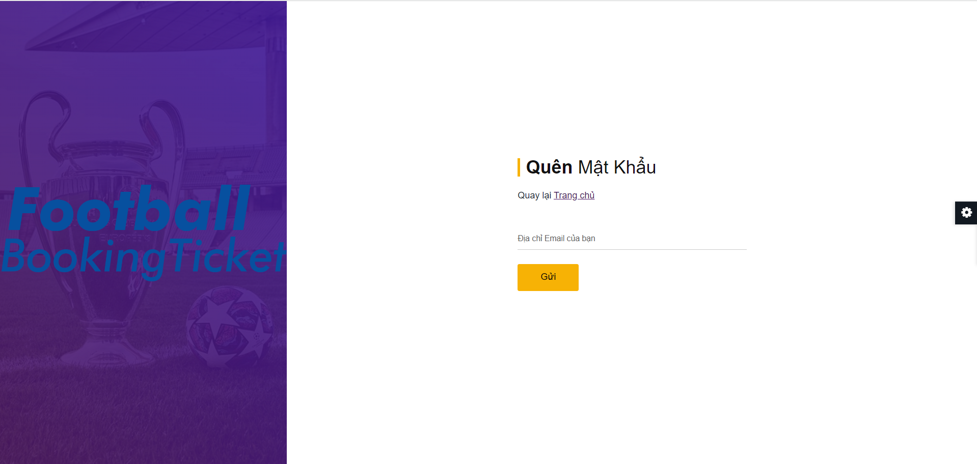

**S2_User Check Their Email**

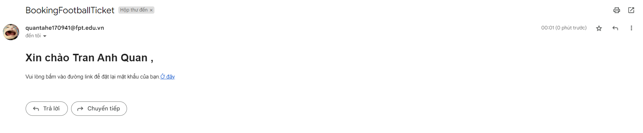

**S3_User Reset Password**

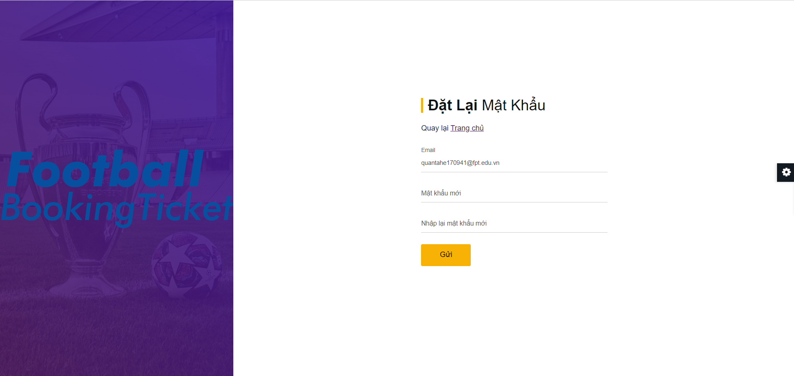

| **Field Name** | **Field Type** | **Description** |
| --- | --- | --- |
| New Password* | String(100) | User enters new password |
| Confirm Password* | String(100) | User enters confirm new password |
| Submit | Button | The user presses submit to change the new password |

#### Database Access

| **Table** | **CRUD** | **Description** |
| --- | --- | --- |
| User | U | Update new password |

## 

### 1.5 My Tickets

This screen allows customers to view their history purchased tickets. Customer can click on ticket to view ticket detail

#### UI Design

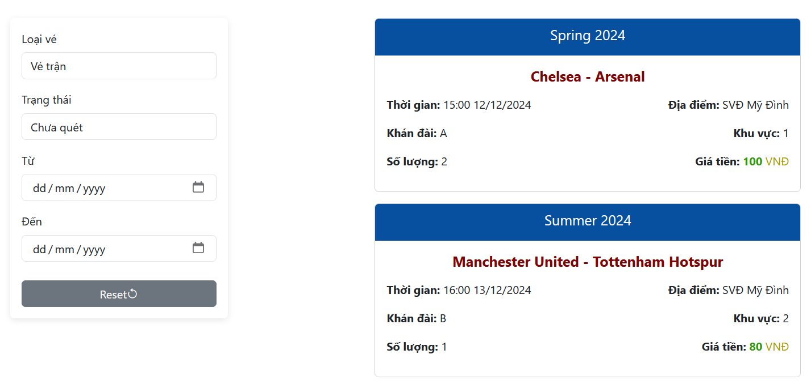

| **Field Name** | **Field Type** | **Description** |
| --- | --- | --- |
| Loại vé | Combobox | Filter by ticket type |
| Trạng thái | Combobox | Filter by ticket status |
| Từ | Date | Filter by date of match |
| Đến | Date | Filter by date of match |
| Reset | Button | Click to reset input in form |
| Pagination(5) | Anchor Link | Pagination list tickets |

#### 

#### Database Access

| **Table** | **CRUD** | **Description** |
| --- | --- | --- |
| HistoryPurchasedTicketMatchSeat | R | List tickets |

### 1.6 My Ticket Detail

This screen display ticket detail that customer were chosen from “My Tickets” screen

#### UI Design

### 

### 

#### Database Access

| **Table** | **CRUD** | **Description** |
| --- | --- | --- |
| HistoryPurchasedTicketMatchSeat | R | Get a ticket |

### 

### 1.7 Profile Edit

This screen displays the profile of this account, user can edit profile.

#### UI Design

### 

### 

#### Database Access

| **Table** | **CRUD** | **Description** |
| --- | --- | --- |
| User | R U | Edit profile |

### 

## 2. Common Access

### 2.1 User Register

This screen allows users to register for an account.

#### UI Design

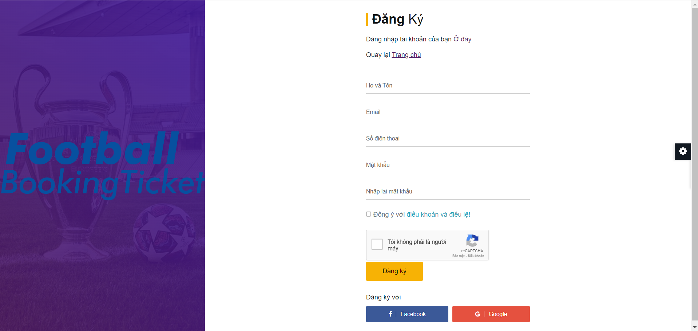

| **Field Name** | **Field Type** | **Description** |
| --- | --- | --- |
| Name* | String(50) | This is for the user to input a name for register |
| Email* | String(50) | This is for user to input valid email address for register |
| Phone number* | String(10) | This is for user to input phone number for register |
| Password* | String(100) | This is for user to create password for register |
| Confirm password* | String(100) | This is for user to confirm password for register |
| Terms and conditions* | Box | Check the box to agree with our terms and conditions |
| Recaptcha* | Box | Requires authentication that the user is not a robot |
| Register | Button | User clicks to register an account |
| Sign in | Hyperlink | The user clicks to go to the login page |
| Register with Google | Button | Allow user to register with his/her Google account |
| Register with Facebook | Button | Allow user to register with his/her Facebook account |

#### Database Access

| **Table** | **CRUD** | **Description** |
| --- | --- | --- |
| User | C | Create new Account |

### 2.2 Cate are password when registering with Gmail

#### UI Design

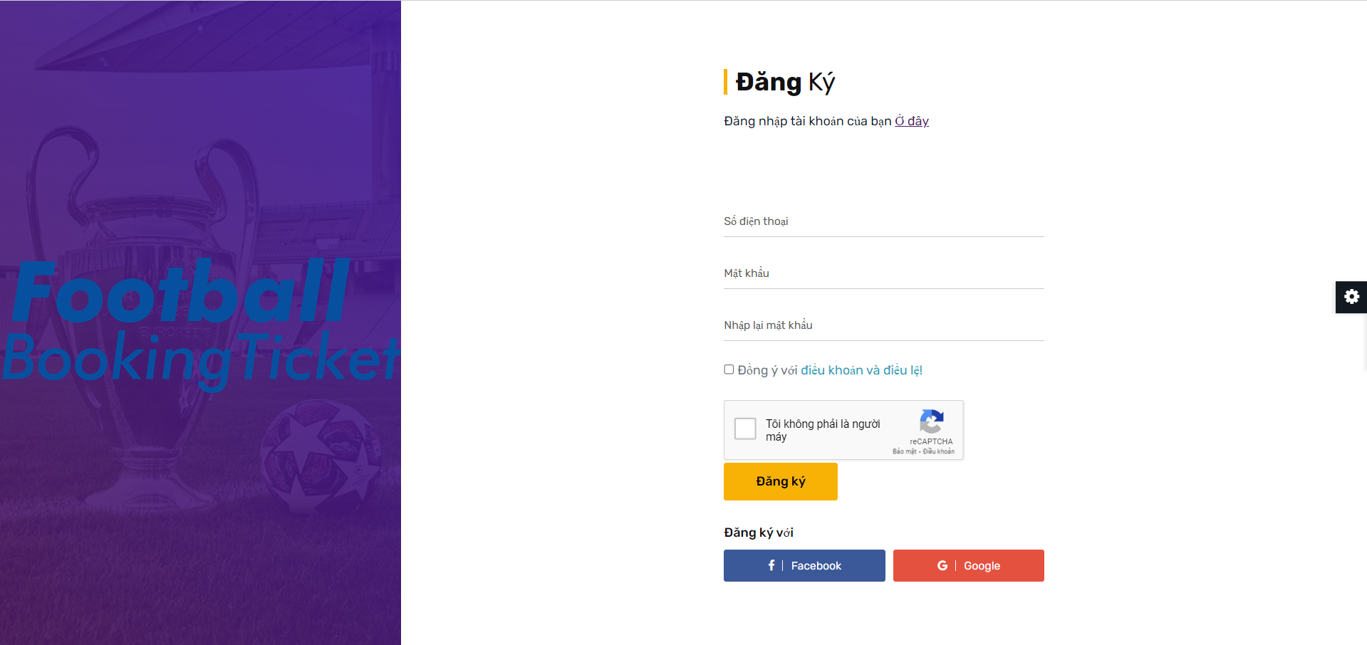

| **Field Name** | **Field Type** | **Description** |
| --- | --- | --- |
| Phone number* | String(10) | This is for user to input phone number for register |
| Password* | String(100) | This is for user to create password for register |
| Confirm password* | String(100) | This is for user to confirm password for register |
| Terms and conditions* | Box | Check the box to agree with out terms and conditions |
| Recaptcha* | Box | Requires authentication that the user is not a robot |
| Register | Button | User clicks to register an account |
| Sign in | Hyperlink | The user clicks to go to the login page |
| Register with Google | Button | Allow user to register with his/her Google account |
| Register with Facebook | Button | Allow user to register with his/her Facebook account |

#### Database Access

| **Table** | **CRUD** | **Description** |
| --- | --- | --- |
| User | C | Create new Account |

### 2.3 Instructions For Buy Tickets

This screen displays ticket purchasing instructions for customers.

#### UI Design

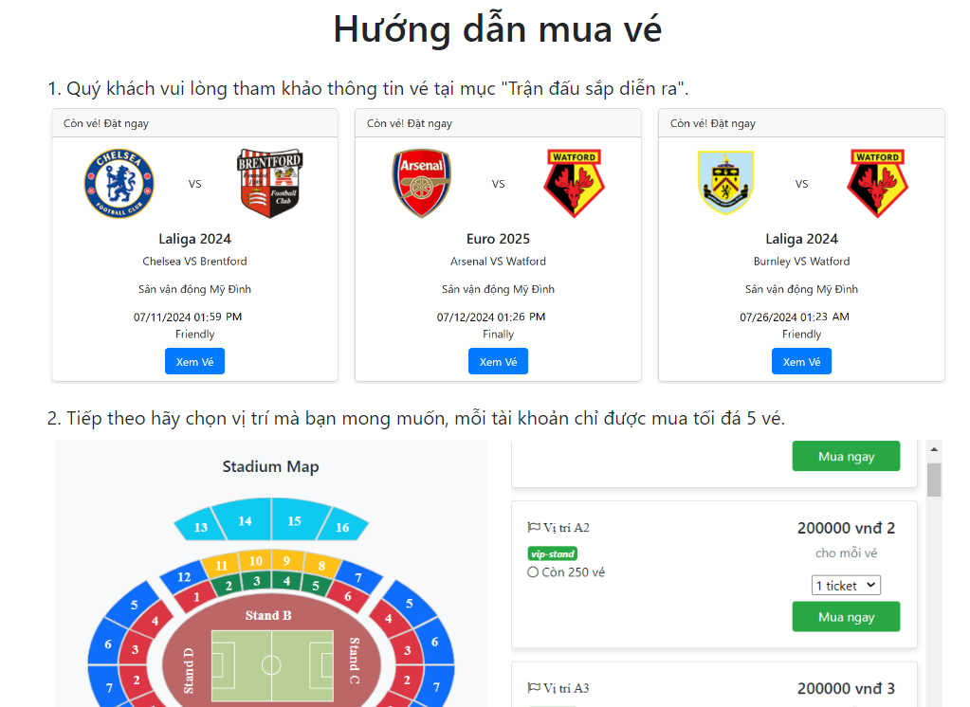

### 2.4 About Us

This screen displays information about the FootballBookingTicket website.

#### UI Design

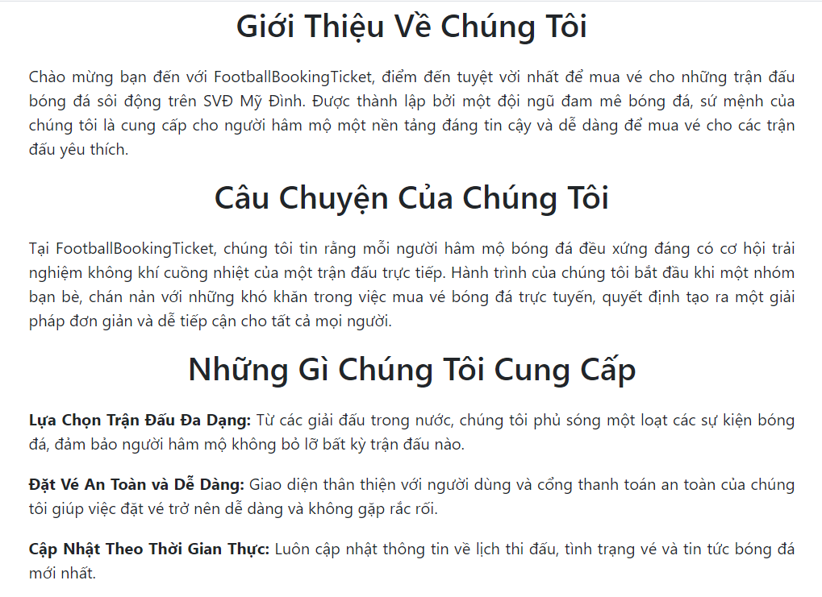

### 2.5 Public Match Detail

This screen displays information about the Detail of each match website.

#### UI Design

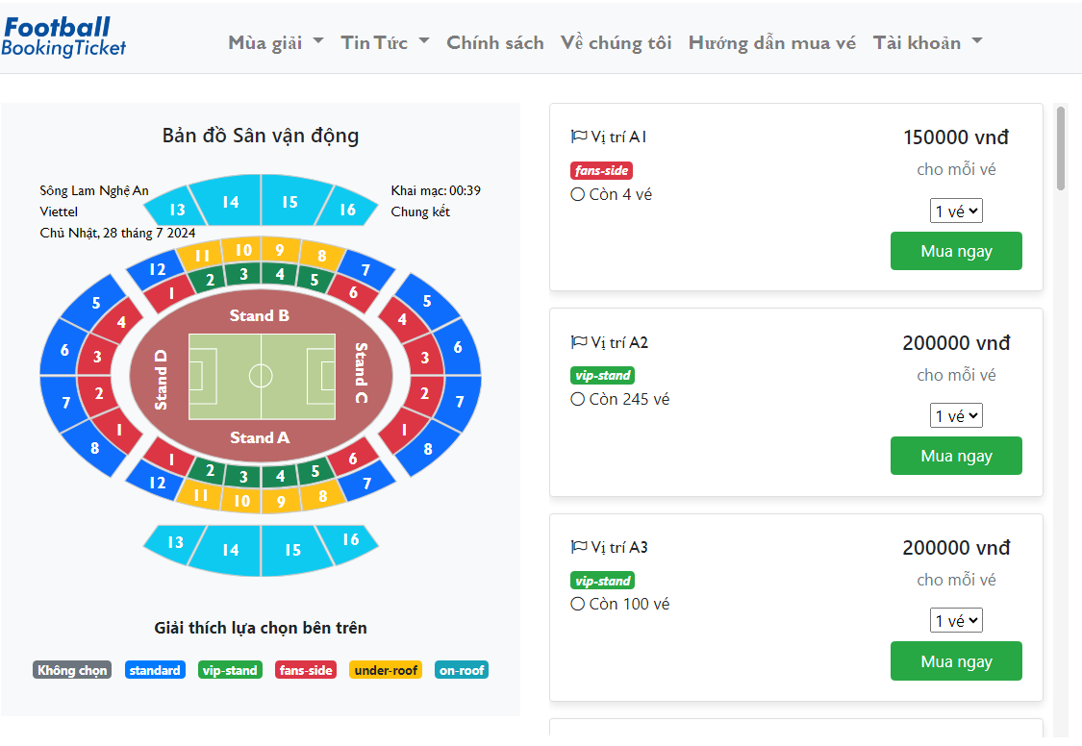

| **Field Name** | **Field Type** | **Description** |
| --- | --- | --- |
| Seat | Path | This is for user select type of Seat, and the screen on the right will display exactly what they selected on the left |
| Mua ngay | Anchor Link | User clicks to pop-up modal Summary ticket |

#### Database Access

#### 

| **Table** | **CRUD** | **Description** |
| --- | --- | --- |
| MatchSeat | R | List matchSeat to display |
| MatchStand | R | get standName info for matchSeat |
| SeatAreaClass | R | get className info for matchSeat |

### 2.6 Summary Ticket

This screen displays information about the Detail of Ticket.

#### UI Design

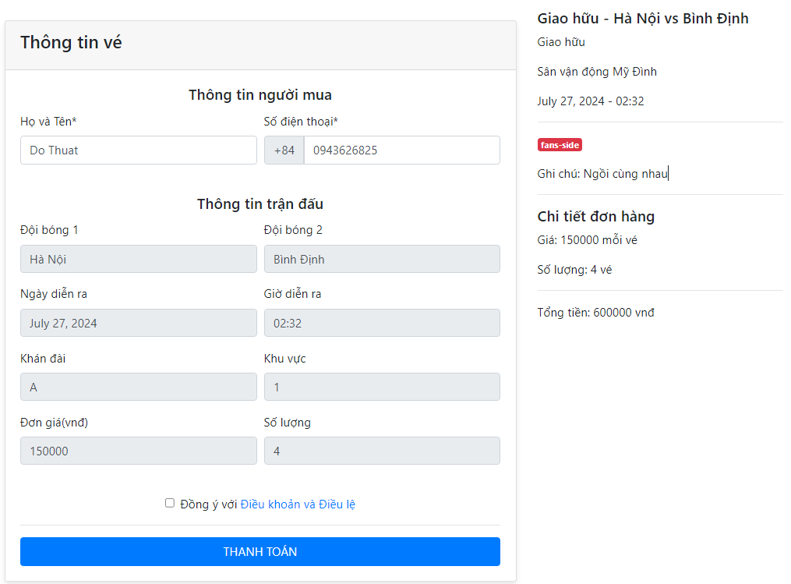

| **Field Name** | **Field Type** | **Description** |
| --- | --- | --- |
| Number of tickets | select | This select for user choose quantity of ticket |
| Thanh Toán | Anchor Link | User clicks to go to the Checkout page. |

#### Database Access

#### 

| **Table** | **CRUD** | **Description** |
| --- | --- | --- |
| MatchSeat | R | List matchSeat to display |
| MatchStand | R | get standName info for matchSeat |
| SeatAreaClass | R | get className info for matchSeat |

### 2.7 Public Match List

This screen displays information about the List of Matches.

#### UI Design

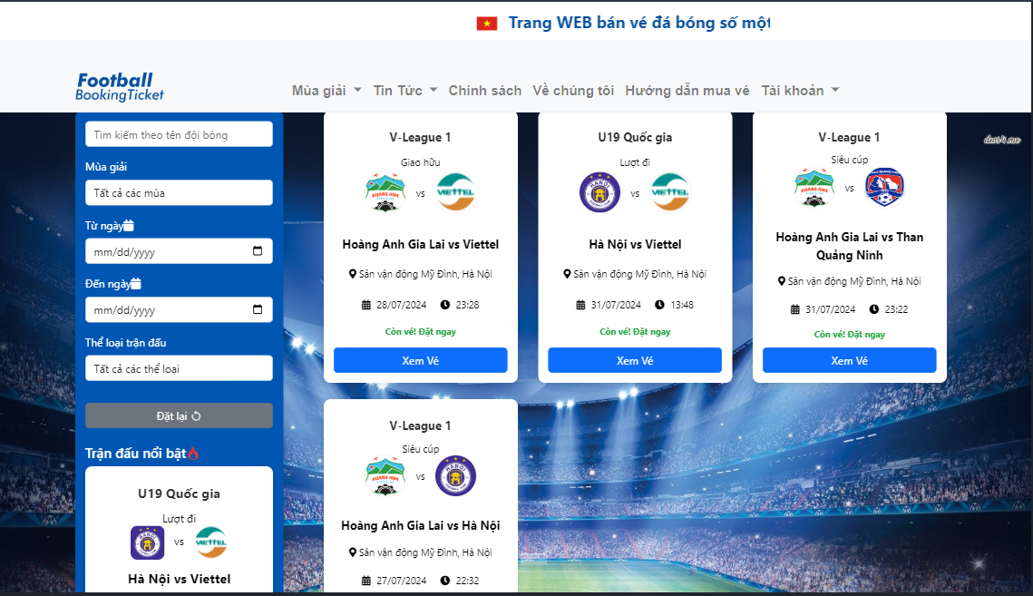

#### 

| **Field Name** | **Field Type** | **Description** |
| --- | --- | --- |
| Tìm kiếm theo tên đội bóng | Text Input | Allows users to search for matches by team name |
| Xem vé | Anchor Link | User clicks to go to View match detail and ticket. |
| Tên mùa | Select | Allows users to filter matches by season |
| Ngày bắt đầu | Date Picker | Allows users to filter matches from a specific start date |
| Ngày kết thúc | Date Picker | Allows users to filter matches up to a specific end date |
| Thể loại trận đấu | Select | Allows users to filter matches by match type |
| Nút đặt lại | Button | Resets all input fields to their default state |

#### Database Access

#### 

| **Table** | **CRUD** | **Description** |
| --- | --- | --- |
| MatchSeat | R | Check if matches still have tickets available |
| Season | R | get seasonName info for matches |
| Match | R | Retrieve match information |

### 2.8 Public Season List

This screen displays information about the List of Season.

#### UI Design

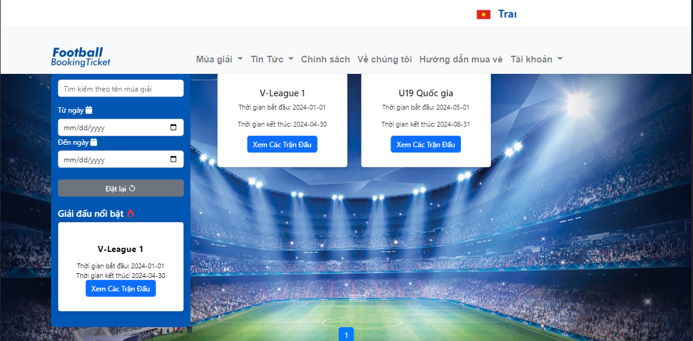

| **Field Name** | **Field Type** | **Description** |
| --- | --- | --- |
| Tên mùa giải đấu | Text Input | Allows users to search for season by season name |
| Xem các trận đấu | Anchor Link | User clicks to go to the View match of the Season. |
| Ngày bắt đầu | Date Picker | Allows users to filter season from a specific start date |
| Ngày kết thúc | Date Picker | Allows users to filter season up to a specific end date |
| Nút đặt lại | Button | Resets all input fields to their default state |

#### Database Access

#### 

| **Table** | **CRUD** | **Description** |
| --- | --- | --- |
| Season | R | get season info |

### 2.9 Public Football Club List

This screen displays information about the List of Football Clubs.

#### UI Design

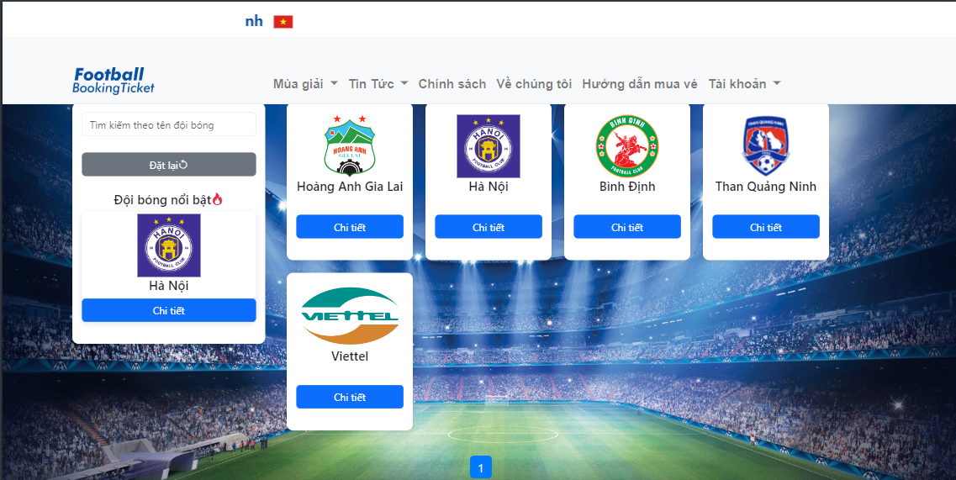

| **Field Name** | **Field Type** | **Description** |
| --- | --- | --- |
| Tên đội bóng | Text Input | Allows users to search for football clubs by team name |
| Nút đặt lại | Button | Resets all input fields to their default state |
| Chi tiết | Anchor Link | User clicks to go to View football club details and matches of them. |

#### Database Access

#### 

| **Table** | **CRUD** | **Description** |
| --- | --- | --- |
| Football Club | R | Get football club info |

### 2.10 Public News List

#### UI Design

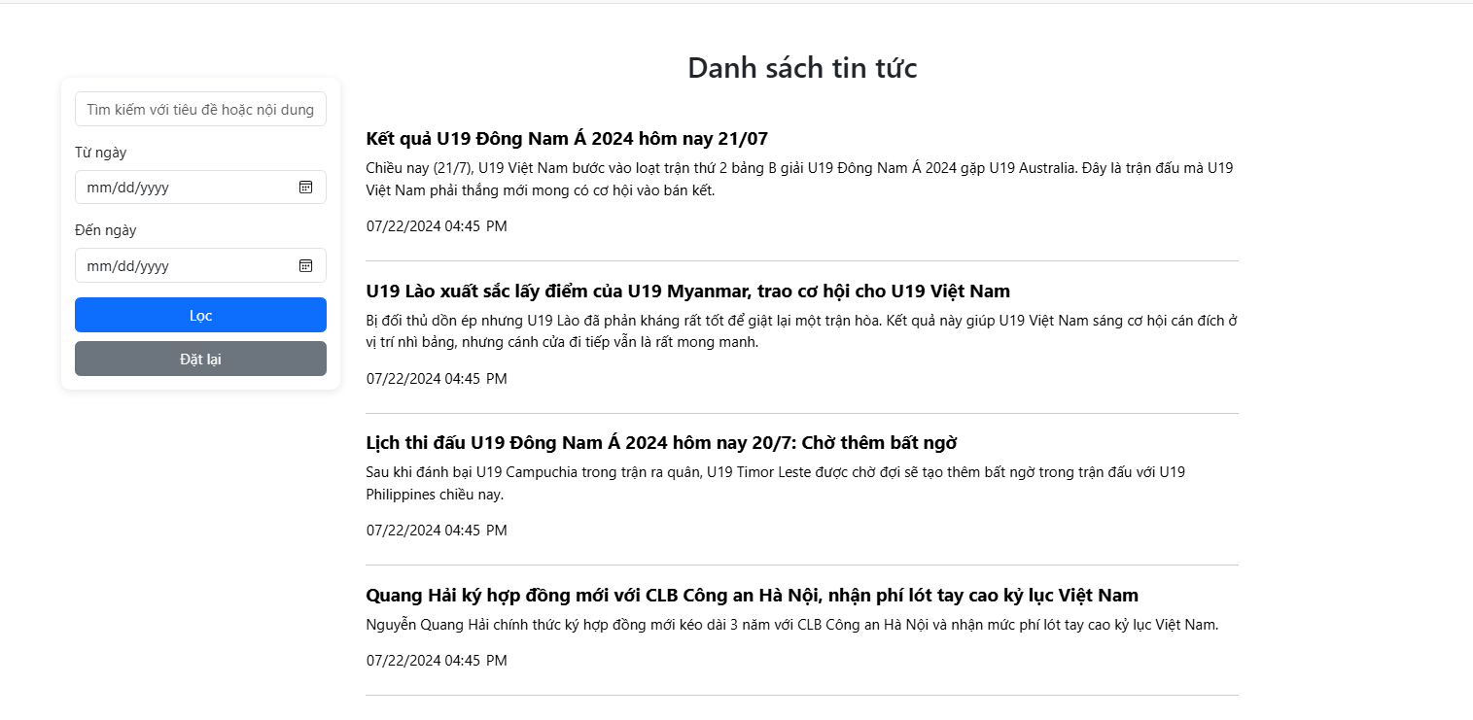

| **Field Name** | **Field Type** | **Description** |
| --- | --- | --- |
| Tìm kiếm với tiêu đề hoặc nội dung | Text Input | Allows users to search for news by title and content |
| Từ Ngày | Date Picker | Allows users to filter news from a specific start date |
| Đến Ngày | Date Picker | Allows users to filter news up to a specific end date |
| Lọc | Button | Executes the filtering based on the selected criteria |
| Đặt lại | Button | Resets all input fields to their default state |

#### Database Access

#### 

| **Table** | **CRUD** | **Description** |
| --- | --- | --- |
| News | R | Get list news info |

### 2.11 Public News Detail

#### UI Design

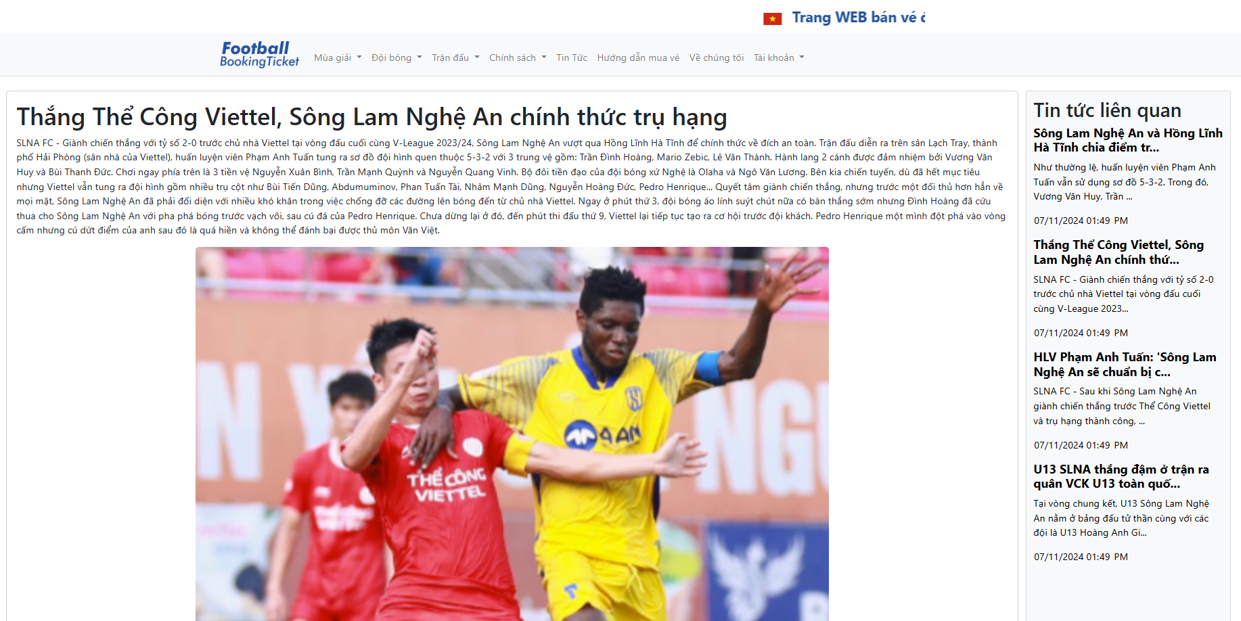

| **Field Name** | **Field Type** | **Description** |
| --- | --- | --- |
| N/A | N/A | N/A |

#### Database Access

#### 

| **Table** | **CRUD** | **Description** |
| --- | --- | --- |
| News | R | get news details information |

### 2.12 Home Page

#### UI Design

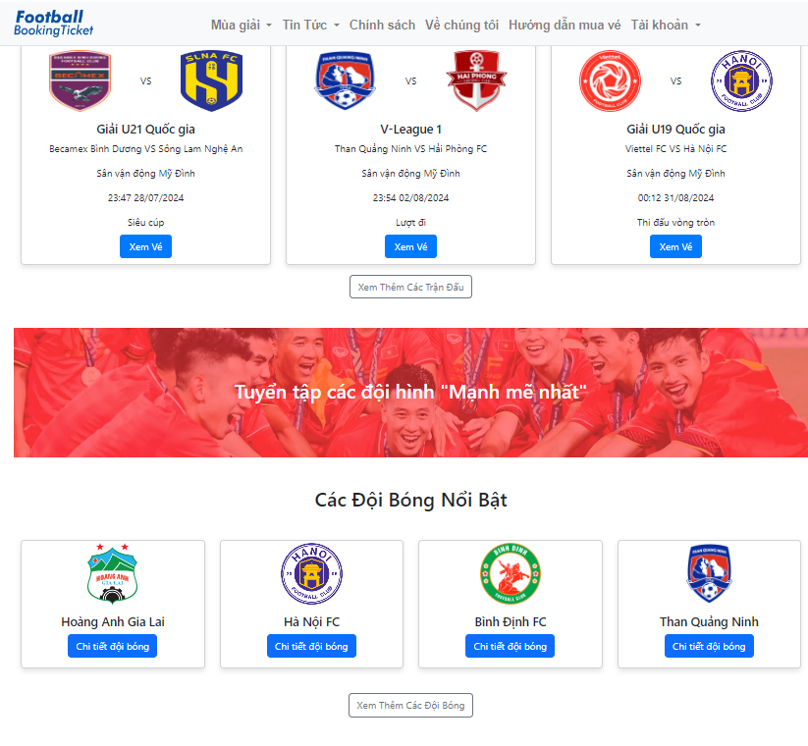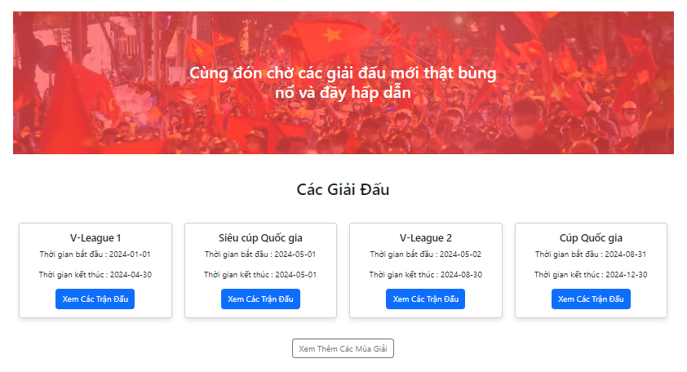

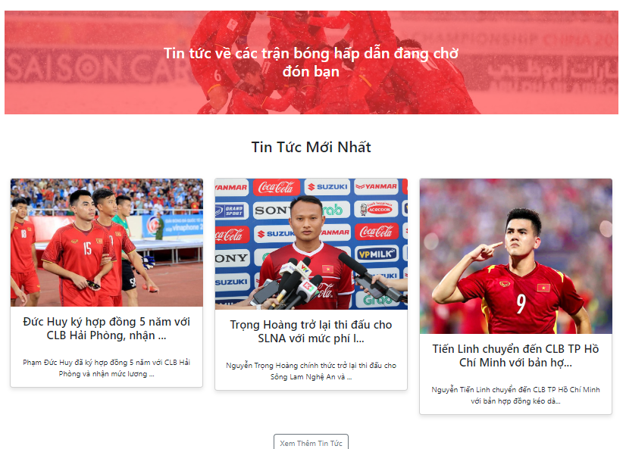

| **Field Name** | **Field Type** | **Description** |
| --- | --- | --- |
| Xem trận đấu | Anchor Link | User clicks to go to view the match. |
| Chi tiết đội bóng | Anchor Link | User clicks to go to view detail about the football club team |
| Xem các trận đấu | Anchor Link | User click to go to have overview about matches in the season |
| Xem Thêm Các Trận Đấu | Anchor Link | User click to go to have overview about matches newest |
| Xem Thêm Các Đội Bóng | Anchor Link | User click to go to have overview about all football club team |
| Xem Thêm Các Mùa Giải | Anchor Link | User click to go to have overview about season newest |
| Xem Thêm Các Tin Tức | Anchor Link | User click to go to have overview about news newest |

#### Database Access

#### 

| **Table** | **CRUD** | **Description** |
| --- | --- | --- |
| News | R | get news information |
| FootballClub | R | get football club information |
| Match | R | get match information |
| Season | R | get season information |

### 

## 3. Stand Management

### 3.1 Stand List

##### 

This screen displays a comprehensive list of stands available in the system, including their names, prices, quantity…. It also has a search bar, create stand button , update and delete icon for each stand in list. Only administrators have access to this screen.

#### UI Design

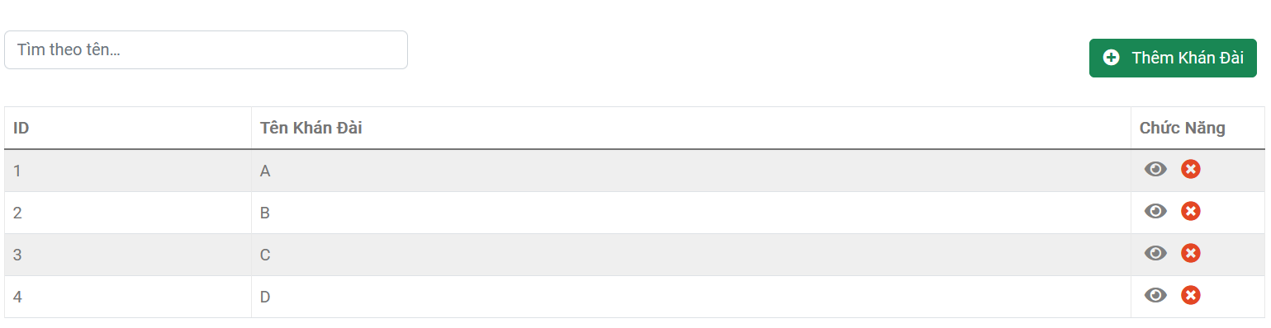

| **Field Name** | **Field Type** | **Description** |
| --- | --- | --- |
| Tìm theo tên | String(50) | This is for user to input valid email address for logging in |
| Thêm Khán Đài | Anchor Link | Admin clicks to pop-up modal create stand |
| Eye Icon | Anchor Link | Admin clicks to pop-up modal to view detail information and update stand |
| Delete Stand Icon | AnchorLink | Admin clicks to pop-up message confirm delete stand |

#### Database Access

| **Table** | **CRUD** | **Description** |
| --- | --- | --- |
| Stand | R | List stands to display |

### 3.2 New Stand

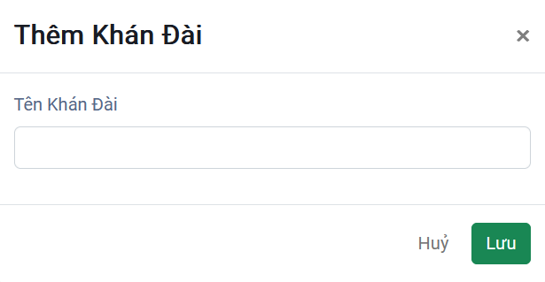

#### UI Design

| **Field Name** | **Field Type** | **Description** |
| --- | --- | --- |
| Tên Khán Đài | String(50) unique | This is for user to input valid stand name for create stand in system |

#### Database Access

| **Table** | **CRUD** | **Description** |
| --- | --- | --- |
| Stand | C | Create stand in database |

### 3.3 Stand Update

#### UI Design

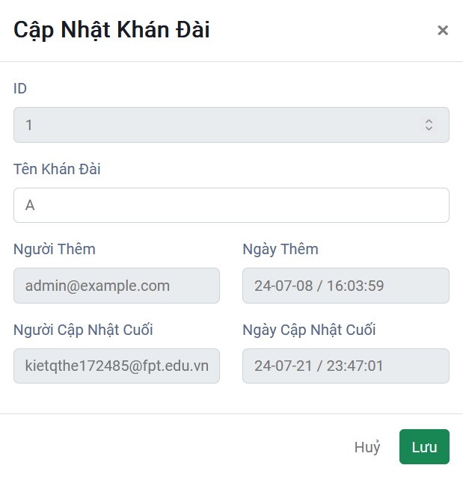

| **Field Name** | **Field Type** | **Description** |
| --- | --- | --- |
| Stand ID | int(readonly)  unique | id of stand |
| Tên Khán Đài | String(50) unique | This is for user to input valid email address for logging in |
| Người Thêm | Email(readonly) | Display email of person who created this stand |
| Ngày Thêm | Date(readonly) | Stand created date |
| Người Cập Nhật Cuối | Email(readonly) | Display email of person who updated stand the last |
| Ngày Cập Nhật Cuối | Date(readonly) | Football club last updated date |
| Lưu | Button | Button to submit form to update stand |
| Huỷ | Button | Close modal create stand |

#### Database Access

| **Table** | **CRUD** | **Description** |
| --- | --- | --- |
| Stand | U | Update exist stand in database |
| Stand | R | Display information of stand were chosen |

## 4. Football Club Management

### 4.1 Football Clubs List

#### UI Design

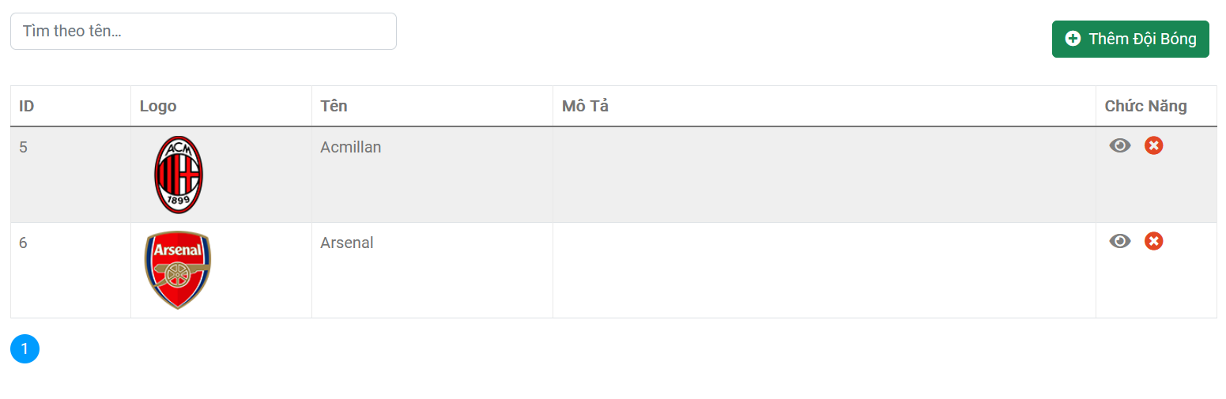

| **Field Name** | **Field Type** | **Description** |
| --- | --- | --- |
| Search | String(50) | Search football club by name |
| Thêm Đội Bóng | Anchor Link | Admin clicks to pop-up modal create football club |
| Eye Icon | Anchor Link | Admin clicks to pop-up modal to view details and update information of football club |
| Delete Club Icon | Anchor Link | Admin clicks to pop-up message confirm delete football club |
| Number at the bottom(1) | Internal Link | Pagination for displaying the football clubs list |

#### Database Access

| **Table** | **CRUD** | **Description** |
| --- | --- | --- |
| FootballClub | R | List Football Clubs to display |

### 4.2 New Football Club

#### UI Design

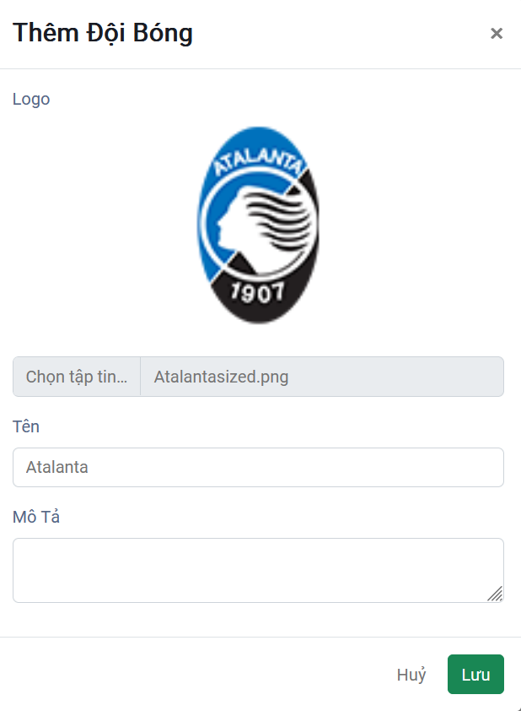

| **Field Name** | **Field Type** | **Description** |
| --- | --- | --- |
| Logo | Image | Upload image for football club |
| Tên | String(50) | Input football club name to create |
| Mô Tả | String(255) | Input description of football club |
| Lưu | Button | Button to submit form to create football club |
| Huỷ | Button | Close modal create football club |

#### Database Access

| **Table** | **CRUD** | **Description** |
| --- | --- | --- |
| FootballClub | C | Create football club |

### 

### 4.3 Football Club Update

#### UI Design

### 

| **Field Name** | **Field Type** | **Description** |
| --- | --- | --- |
| ID | Int(readonly) | This is id of football club |
| Logo | Image | Upload new image for football club |
| Tên | String(50) | Input football club name to update |
| Mô Tả | String(255) | Input description of football club |
| Người Tạo | Email(readonly) | Display email of person who created this football club |
| Ngày Tạo | Date(readonly) | Football club created date |
| Người Cập Nhật Cuối | Email(readonly) | Display email of person who updated football club the last |
| Ngày Cập Nhật Cuối | Date(readonly) | Football club last updated date |
| Lưu | Button | Button to submit form to update football club |
| Huỷ | Button | Close modal create football club |
|  |  |  |

#### Database Access

| **Table** | **CRUD** | **Description** |
| --- | --- | --- |
| FootballClub | R | List exist football clubs in system |
| FootballClub | U | Update exist football club in system |

### 

## 5. Match Management

### 5.1 Match List

##### 

This screen displays a comprehensive list of matches available in the system, including their ID, Football Club 1 and 2, start time, season, status, type…. It also has a search bar, create stand button, and update and delete icon for each row in the list. Only administrators have access to this screen.

#### UI Design

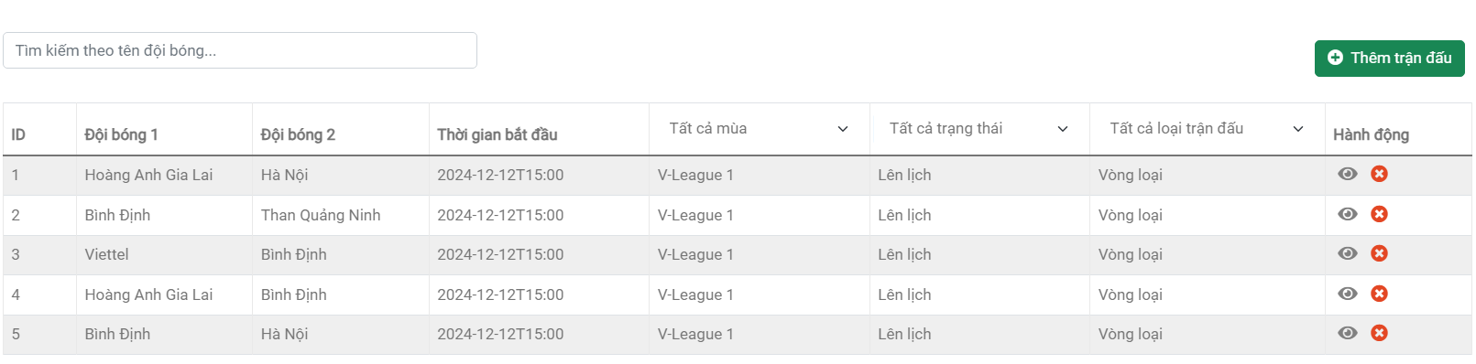

| **Field Name** | **Field Type** | **Description** |
| --- | --- | --- |
| Tìm kiếm | String(50) | This is for the user to input a valid name of match |
| Thêm trận đấu | Anchor Link | Admin clicks to pop-up modal to create the match. |
| Cập nhật trận đấu | Anchor Link | Admin clicks to pop-up modal to update the match. |
| Huỷ trận đấu | AnchorLink | Admin clicks to pop-up message confirm delete match. |

#### Database Access

| **Table** | **CRUD** | **Description** |
| --- | --- | --- |
| Match | R | The list matches to display. |

### 5.2 New Match

#### UI Design

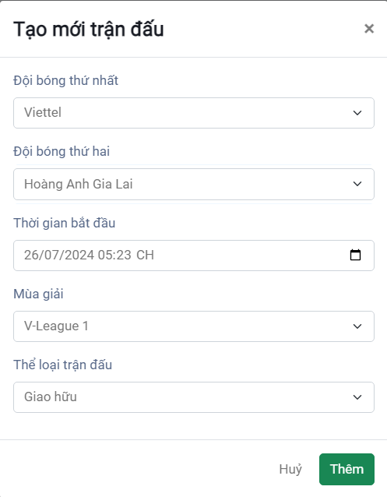

| **Field Name** | **Field Type** | **Description** |
| --- | --- | --- |
| Đội bóng thứ nhất | Select | This allows the admin to choose a team different from the second team. |
| Đội bóng thứ hai | Select | This allows the admin to choose a team different from the first team. |
| Thời gian bắt đầu | datetime2 | This is for the admin to input a valid date for the start time of the match. |
| Mùa giải | Select | This is for the admin to choose the valid season. |
| Thể loại trận đấu | Select | This allows the admin to choose the type of match. |

#### Database Access

| **Table** | **CRUD** | **Description** |
| --- | --- | --- |
| Match | C | Create match in database |
| MatchType | R | Read data to fill dropdown |
| MatchStatus | R | Read data to fill dropdown |
| Season | R | Read data to fill dropdown |

### 5.3 Match Update

#### UI Design

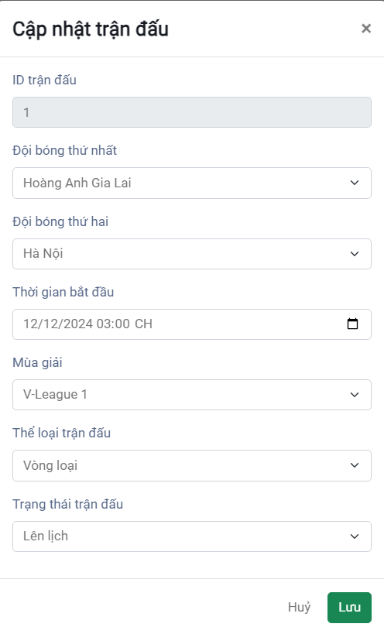

| **Field Name** | **Field Type** | **Description** |
| --- | --- | --- |
| Đội bóng thứ nhất | Select | This allows the admin to choose a team different from the second team. |
| Đội bóng thứ hai | Select | This allows the admin to choose a team different from the first team. |
| Thời gian bắt đầu | datetime2 | This is for the admin to input a valid date for the start time of the match. |
| Mùa giải | Select | This is for the admin to choose the valid season. |
| Thể loại trận đấu | Select | This allows the admin to choose the type of match. |
| Trạng thái trận đấu | Select | This allows the admin to choose the valid status. |

#### Database Access

| **Table** | **CRUD** | **Description** |
| --- | --- | --- |
| Match | U | Update exist Match in database |
| Match | R | Display information of stand were chosen |

### 5.4 Delete Matches

#### UI Design

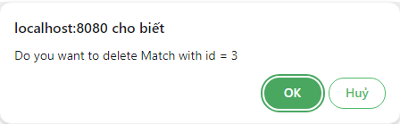

| **Field Name** | **Field Type** | **Description** |
| --- | --- | --- |
| OK | Button | This is a button for the admin to confirm the deletion. |
| Hủy | Button | This is a button for the admin to cancel the deletion. |

#### Database Access

| **Table** | **CRUD** | **Description** |
| --- | --- | --- |
| Match | U | Update Match’s attribute “isDeleted” to 1 |

## 6. User Management

### 6.1 User List

This screen displays a comprehensive list of users available in the system, including their ID, user name,email, phone number, avatar, name,... It also has a search bar and style of search(user id,username,name), create user button, and update and delete icon for each row in the list,1 page can display 10 users. Only administrators have access to this screen.

#### UI Design

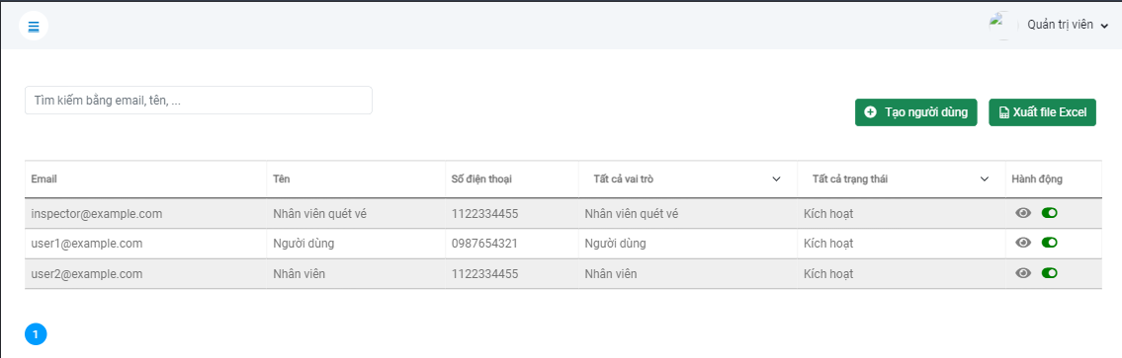

| **Field Name** | **Field Type** | **Description** |
| --- | --- | --- |
| Tìm kiếm | String(50) | This is for the user to input a valid name or user name or user id |
| Tạo người dùng | Anchor Link | Admin clicks to pop-up modal to create a new user. |
| Biểu tượng xem và thay đổi | Anchor Link | Admin clicks to pop-up modal to update the user. |
| Biểu tượng Thay đổi trạng thái người dùng | AnchorLink | Admin clicks to pop-up message confirm delete user. |

#### Database Access

| **Table** | **CRUD** | **Description** |
| --- | --- | --- |
| User | R | The list users to display. |

### 6.3 Create User

##### 

#### UI Design

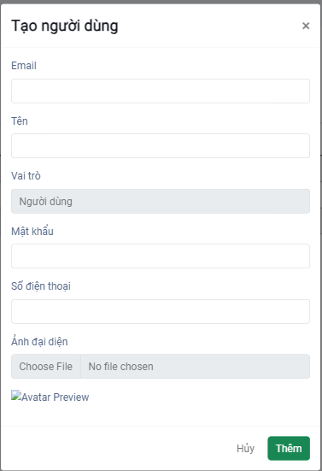

| **Field Name** | **Field Type** | **Description** |
| --- | --- | --- |
| Email | Text | This allows the admin to write email for Account they want create |
| Tên | Text | This allows the admin to write name for Account they want create |
| Vai trò người dùng | Select | This is for the admin to select the role for User they want create |
| Mật khẩu | Text | This is for the admin to write password for Account they want create |
| Số điện thoại | Text | This allows the admin to write a Phone Number for the Account they want to create. |
| Chọn tệp ảnh | Image | Upload image for Account |

#### Database Access

| **Table** | **CRUD** | **Description** |
| --- | --- | --- |
| User | C | Create new Account |

### 6.4 User Update

#### UI Design

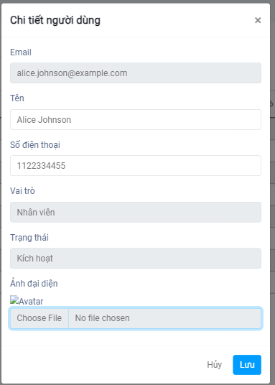

| **Field Name** | **Field Type** | **Description** |
| --- | --- | --- |
| Email | Text | This allows the admin to see email of Account |
| Tên | Text | This allows the admin to see and update name for Account they want update |
| Vai trò người dùng | Text readonly | This is for the admin to see the role of User |
| Trạng thái người người dùng | Text readonly | This is for the admin to see the status of User |
| Số điện thoại | Text | This allows the admin to update the Phone Number of the Account. |
| Chọn tệp ảnh | Image | Upload image for Account |

#### Database Access

| **Table** | **CRUD** | **Description** |
| --- | --- | --- |
| User | R | Read Account |
| User | U | Update Account |

## 7. Season Management

### 7.1 Season List

This screen displays a comprehensive list of seasons available in the system, including their ID, season name,start date,end date,... It also has a search bar and creates a new season button, update and delete icon for each row in the list,1 page can display 10 seasons. Only administrators have access to this screen.

#### UI Design

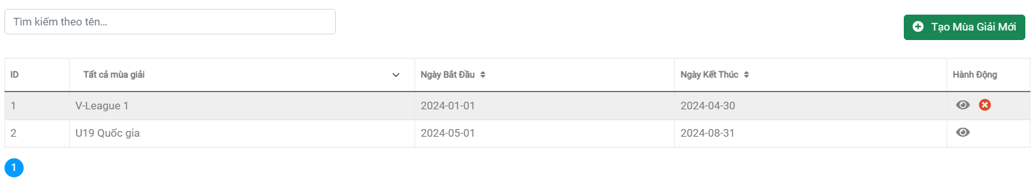

| **Field Name** | **Field Type** | **Description** |
| --- | --- | --- |
| Tìm kiếm | String(50) | This is for the user to input a valid name of the season |
| Tạo mùa giải mới | Anchor Link | Admin clicks to pop-up modal to create a new season. |
| Cập nhật mùa giải | Anchor Link | Admin clicks to pop-up modal to update the season. |
| Xoá mùa giải | AnchorLink | Admin clicks to pop-up message confirm delete the season. |

#### Database Access

| **Table** | **CRUD** | **Description** |
| --- | --- | --- |
| Season | R | The list seasons to display. |

### 7.2 New Season

This pops up so admins can create a new season.

#### UI Design

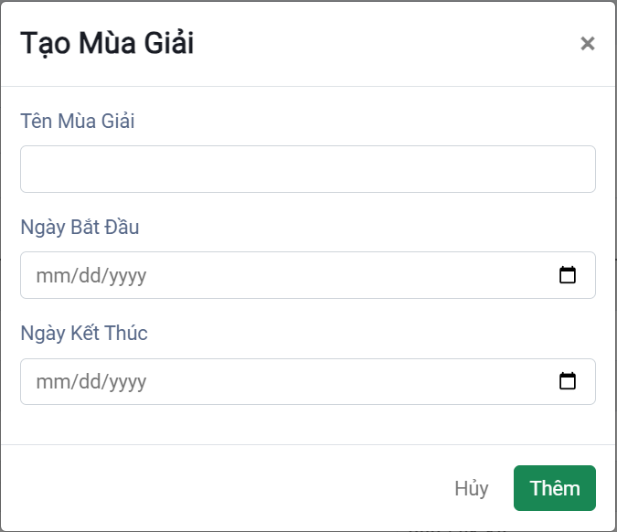

| **Field Name** | **Field Type** | **Description** |
| --- | --- | --- |
| Tên mùa giải | String(50) | Admin can enter the name of the new season. |
| Ngày bắt đầu | Datetime2 | Admin can choose the start date of the season. |
| Ngày kết thúc | Datetime2 | Admin can choose the end date of the season. |

#### Database Access

| **Table** | **CRUD** | **Description** |
| --- | --- | --- |
| Season | C | Create new Season |

## 8. News Management

### 8.1. News List

This screen displays a comprehensive list of news in the system, including their title, content…v.v. It also has a search bar, create stand button , update and delete icon for each news in list. Only administrators have access to this screen.

#### UI Design

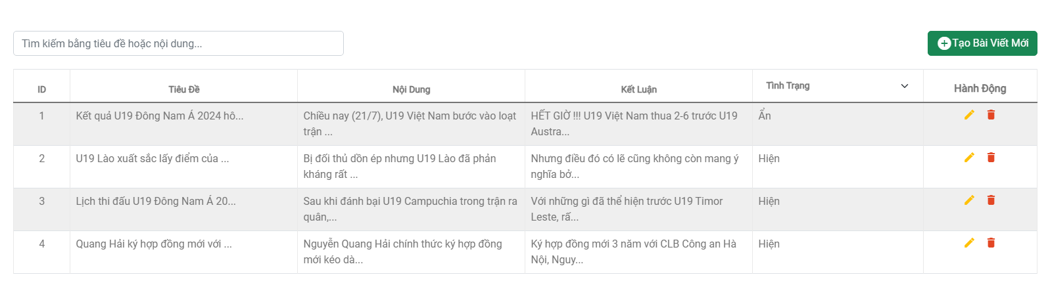

| **Field Name** | **Field Type** | **Description** |
| --- | --- | --- |
| Tìm kiếm bằng tiêu tiêu đề hoặc nội dung | String(50) | This is for the admin to input valid title, content to search |
| Tạo bài viết mới | Anchor Link | Admin clicks to pop-up modal create news |
| Cập nhật tin tức | Anchor Link | Admin clicks to pop-up modal update news |
| Xóa tin tức | AnchorLink | Admin clicks to pop-up message confirm delete news |

#### Database Access

| **Table** | **CRUD** | **Description** |
| --- | --- | --- |
| News | R | List news to display |

### 8.2. New News

#### UI Design

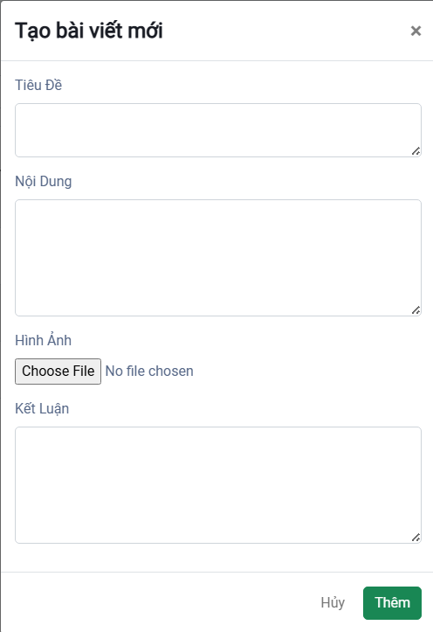

| **Field Name** | **Field Type** | **Description** |
| --- | --- | --- |
| Tiêu đề | String(100) | This is for user to input valid title for create news in system |
| Nội dung | String(350) | This is for user to input valid content for create news in system |
| Hình ảnh | String(50) | This is for user to input valid image for create news in system |
| Kết luận | String(350) | This is for user to input valid conclusion for create news in system |

#### Database Access

| **Table** | **CRUD** | **Description** |
| --- | --- | --- |
| News | C | Create news in database |

### 8.3 News Update

#### UI Design

# 

| **Field Name** | **Field Type** | **Description** |
| --- | --- | --- |
| Tiêu đề | String(100) | This is for user to input valid title for update news in system |
| Nội dung | String(350) | This is for user to input valid content for update news in system |
| Hình ảnh | String(50) | This is for user to input valid image for update news in system |
| Kết luận | String(350) | This is for user to input valid conclusion for update news in system |
| Tình trạng | boolean | This is for user to select status for update news in system |

#### Database Access

| **Table** | **CRUD** | **Description** |
| --- | --- | --- |
| News | U | Update exist news in database |
| News | R | Display information of news were chosen |

## 9. Ticket Management

### 9.1. Ticket Match Seat List

This screen displays a comprehensive list of ticket match seats in the system, including their season, stand, seat…v.v. It also has a search bar. Only administrators have access to this screen.

#### UI Design

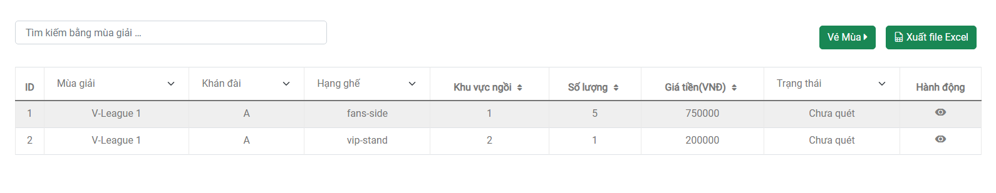

| **Field Name** | **Field Type** | **Description** |
| --- | --- | --- |
| Tìm kiếm | String(50) | This is for the admin to input the season name to search. |

#### Database Access

| **Table** | **CRUD** | **Description** |
| --- | --- | --- |
| Ticket Match Seat | R | List ticket match seat to display |

### 9.2. Ticket Match Season Seat List

This screen displays a comprehensive list of ticket season seats in the system, including their season, stand, seat…v.v. It also has a search bar. Only administrators have access to this screen.

#### UI Design

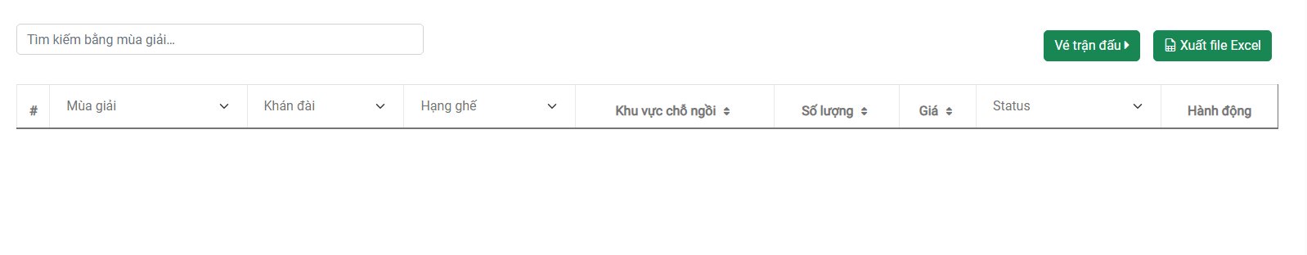

| **Field Name** | **Field Type** | **Description** |
| --- | --- | --- |
| Tìm kiếm | String(50) | This is for the admin to input the season name to search. |

#### Database Access

| **Table** | **CRUD** | **Description** |
| --- | --- | --- |
| Ticket Match Seat | R | List ticket season seat to display |

## 10. Dashboard

#### UI Design

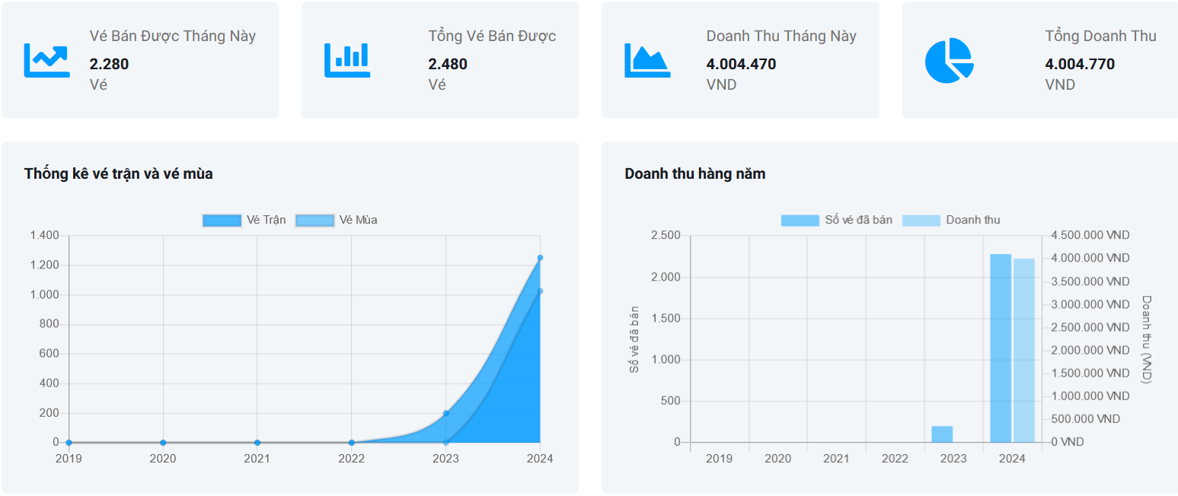

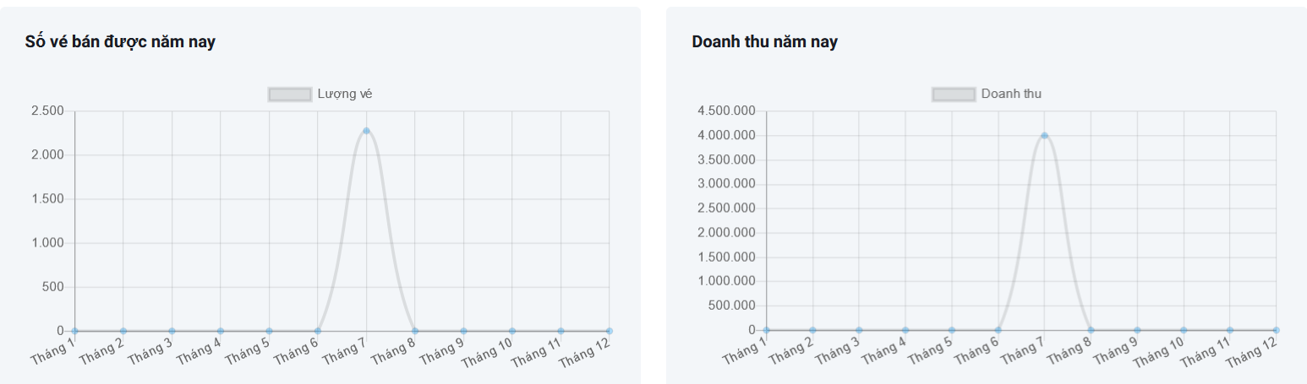

#### Database Access

| **Table** | **CRUD** | **Description** |
| --- | --- | --- |
| HistoryPurchaseTicketMatchSeat | R | Get information to generate chart |
| HistoryPurchaseTicketSeasonSeat | R | Get information to generate chart |

# IV. Code Designs

## 1. Payment Method

### 1.1 Class Diagram

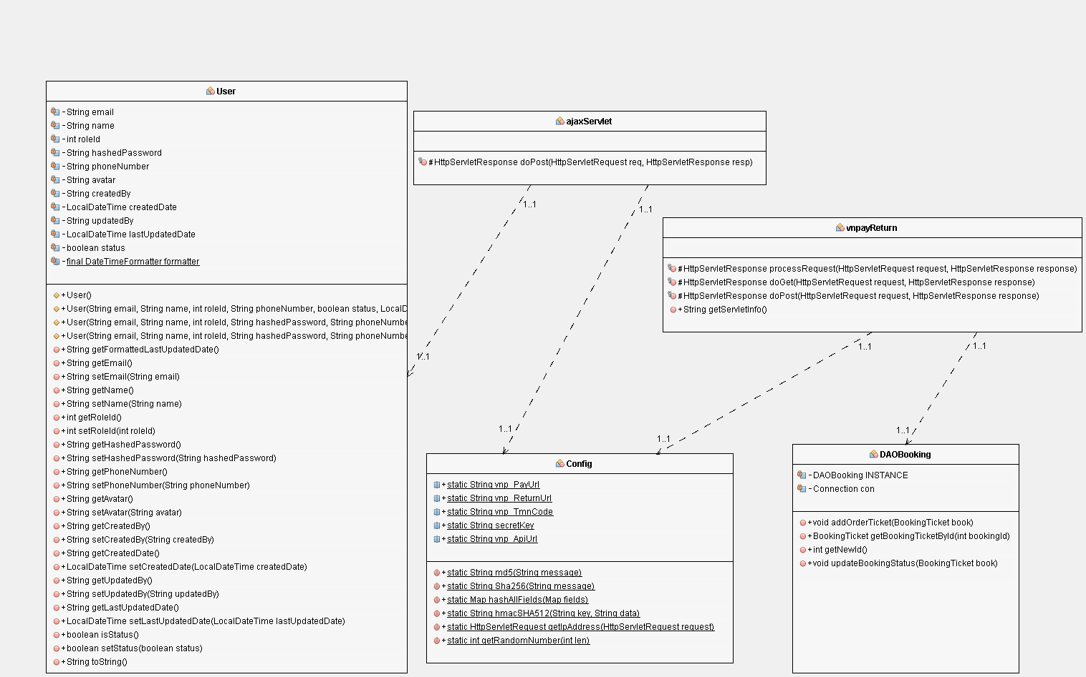

### 1.2 Sequence Diagram(s)

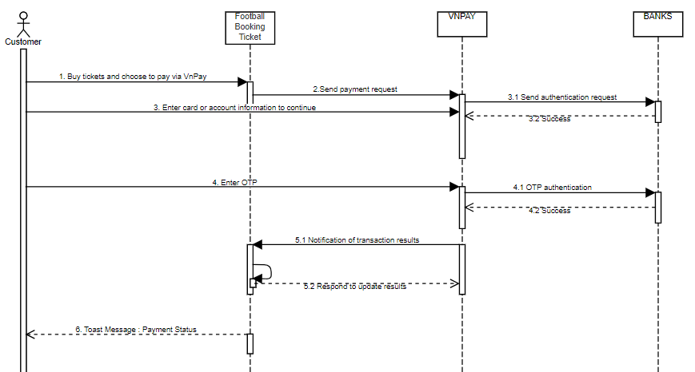

### 1.3 Database Queries

INSERT INTO [dbo].[BookingTicket]

([seatName]

,[quantity]

,[standName]

,[seatClassName]

,[email]

,[qrCode]

,[price]

,[status]

,[createdDate]

,[matchId]

,[matchSeatId])

VALUES(?, ?, ?, ?, ?, ?, ?, ?, ?, ?, ?)

SELECT * FROM [dbo].[BookingTicket] WHERE [bookingId] = ?

UPDATE [dbo].[BookingTicket] SET [status] = ? WHERE [bookingId] = ?

## 2. News List

### 2.1 Class Diagram

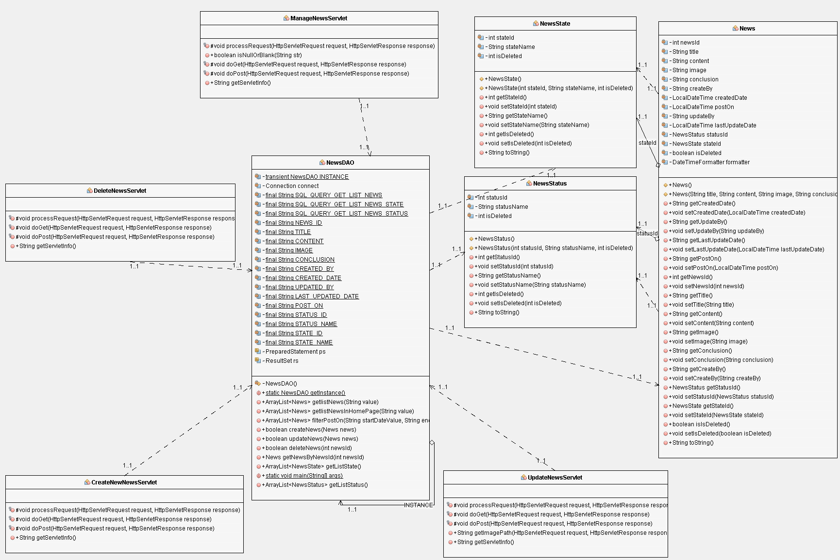

### 2.2 Sequence Diagram(s)

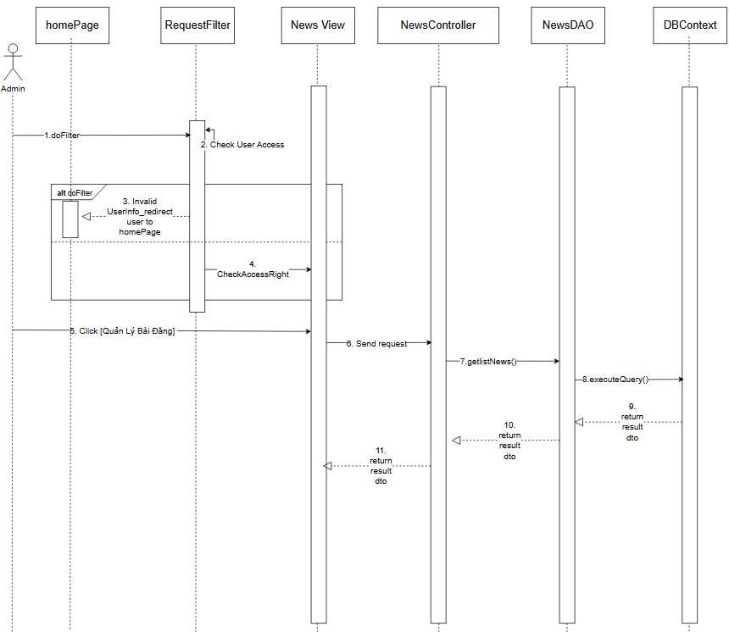

### 2.3 Database Queries

SELECT news.*, newsState.stateName, newsStatus.statusName

FROM News news

JOIN NewsStatus newsStatus ON newsStatus.statusId = news.statusId

JOIN NewsState newsState ON newsState.stateId = news.stateId

WHERE (title LIKE ? OR content LIKE ?) AND news.isDeleted = 0

## 3. Create News

### 3.1 Class Diagram



### 3.2 Sequence Diagram(s)

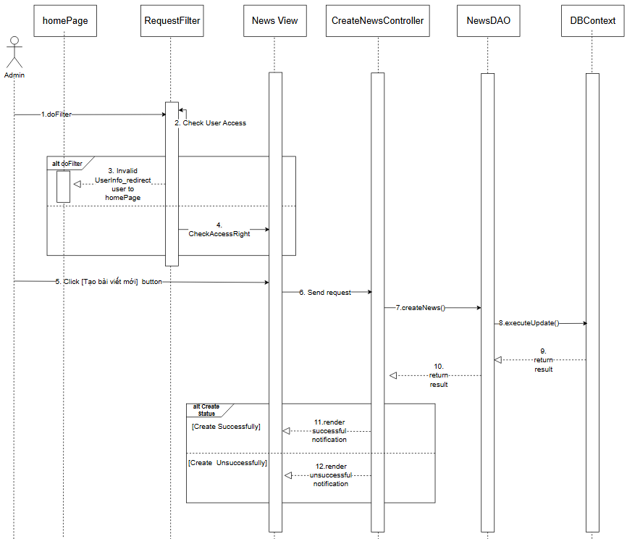

### 3.3 Database Queries

INSERT INTO [News] ([title],[content],[image],[conclusion],[statusId],[stateId],[createdBy]) VALUES(?,?,?,?,?,?,?)

## 4. Update News

### 4.1 Class Diagram



### 4.2 Sequence Diagram(s)

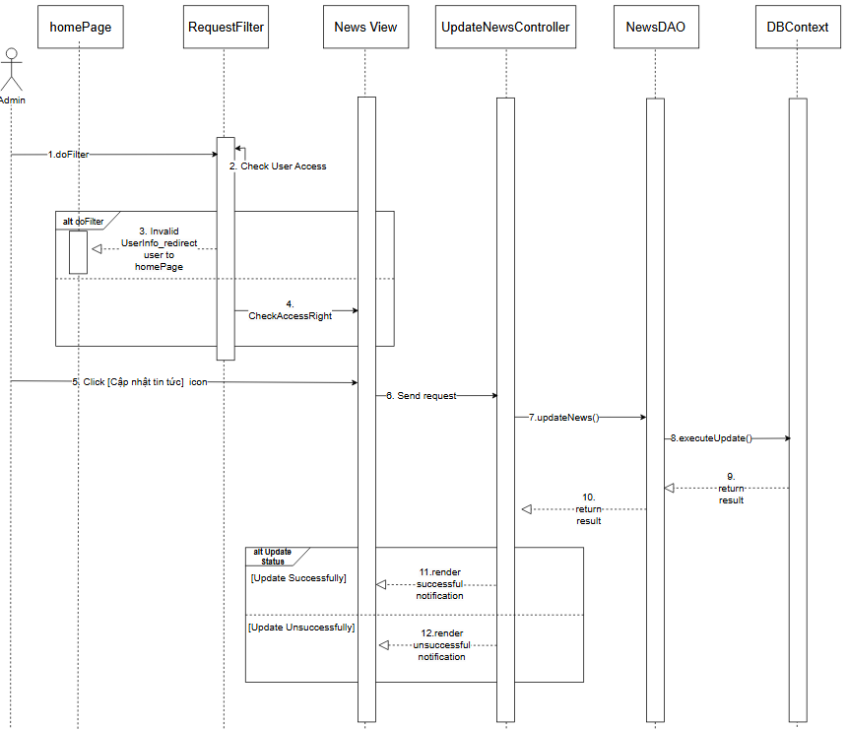

### 4.3 Database Queries

UPDATE [News]

SET [title] = ?

, [content] = ?

,[conclusion] = ?

,[image] = ?

,[statusId] = ?

,[stateId] = ?

,[updatedBy] = ?

WHERE newsId =?

# V. Appendix

## 1. Assumptions & Dependencies

AS-1: It is assumed that the user interface will be designed to be compatible with popular web browsers such as Chrome, Firefox and Safari and all versions such as phones, iPads, etc..

AS-2: Assume that all payment transactions will be paid through many different payment gateways, not just VNPay..

DE-1: Developing system functionality will depend on completing the user interface and user experience (UI/UX) design.

DE-2: User login with Facebook depends on the Web site being registered as a "Business Profile".

DE-3: Functionalities related to external service integration such as online payments will depend on availability and successful integration with third parties providing these services.

## 2. Limitations & Exclusions

LI-1: Only log in with Facebook when registered for "Meta for Developer". If you want everyone to be able to log in with Facebook, you must register for "Business Profile".

LI-2: This website does not support all versions, only web and mobile browser platforms.

LI-3: The system does not support multiple languages ​​for users, only supports 1 language (Vietnamese).

LI-5: The system only supports 1 payment is VNPay and does not support multiple payment channels like other e-wallets other than the integrated gateway.

LI-6: The system does not provide 24/7 customer support. All support requests via email or customer phone number.

LI-7: In this demo version, we only use the phone to scan tickets and do not have a specialized device to scan tickets, so when scanning the QR code, we still have to click on the link to run.

## 3. Business Rules

| **ID** | **Category** | **Rule Definition** |
| --- | --- | --- |
| BR-01 | Authentication | User’s password must be encoded with MD5 hashing |
| BR-02 | Users can’t be authenticated to login the system if user logging-in details are incorrect. |
| BR-03 | Users can’t be authenticated to login the system if the user account has not been verified. |
| BR-04 | Users can be authenticated using Google login and need to create a password. |
| BR-05 | Email must be an email that has never been registered with the system. |
| BR-06 | The phone number must be in the correct format with the phone number in Vietnam. |
| BR-07 | Passwords must be 8 characters or more in length, including lowercase letters, at least 1 uppercase character and 1 number character. |
| BR-08 | Users are required to agree to our terms and conditions to register. |
| BR-09 | When registering, all fields must be filled in properly (not all spaces). |
| BR-10 | Email must be in the correct format. |
| BR-11 | Football Club Management | When create or update a Football Club, name can not be empty and duplicate |
| BR-12 | Stand Management | When create or update a Football Club, name can not be empty and duplicate |
| BR-13 | Match Management | When create or update a Match, the start time must be greater than the current time, and must not coincide with the start time of other matches and must not be 10 hours after that match. |
| BR-14 | Newly created matches will default to scheduling status. |
| BR-15 | The match status will be automatically updated to the finished status 1 hour before the match starts. |
| BR-16 | If the match is in canceled status, it cannot be edited anymore. |
| BR-17 | User Management | When creating or updating a User, email can not be empty and duplicate and when created need a password with 6-8 characters,1 Uppercase. |
| BR-18 | News Management | When create or update a News, title, content, conclusion can not be empty |
| BR-19 | User Access | When customer filter ticket by date, if customer only choose one date, system display ticket from that date to now or to past base on which date customer choose |
| BR-20 | Tickets display order by created date descending |
| BR-21 | Season Management | When create or update a Season, name season can not be empty and cannot create season have the range in range of last season created and cannot delete season when current time is in the range day of that season |

## 